Multiple Access Control Protocol or Medium Access Control Protocol

Data link Layer is divided into LLC and MAC

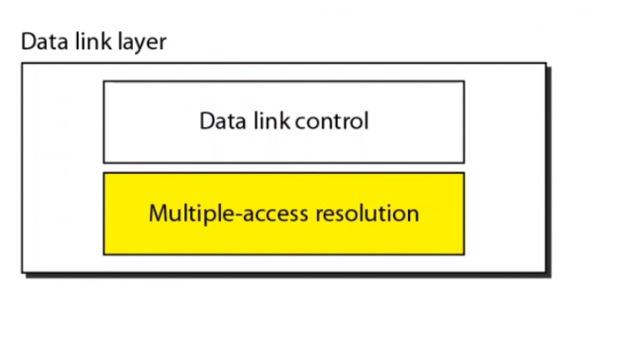

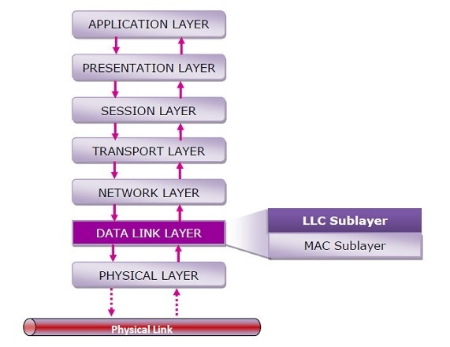

LLC communicates with Network layer, and MAC communicates with Physical layer.

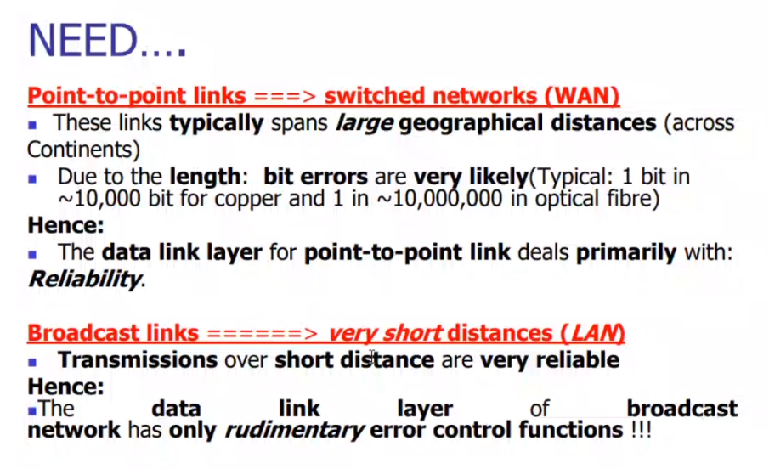

MAC is used   
How to avoid the collision?   
How to survive with the collision?

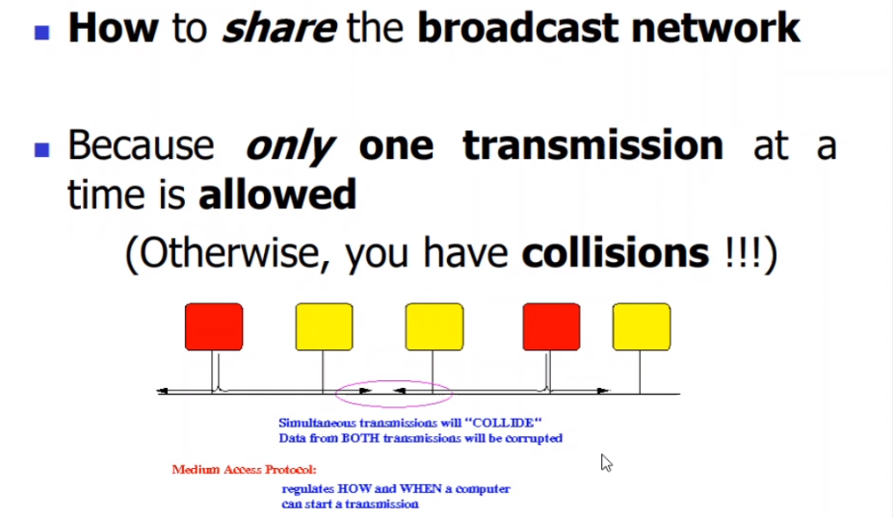



2 red’s must communicate with each-other. So it will communicate.  
If 2 yellow’s also starts communicating with each-other, then collision takes place.

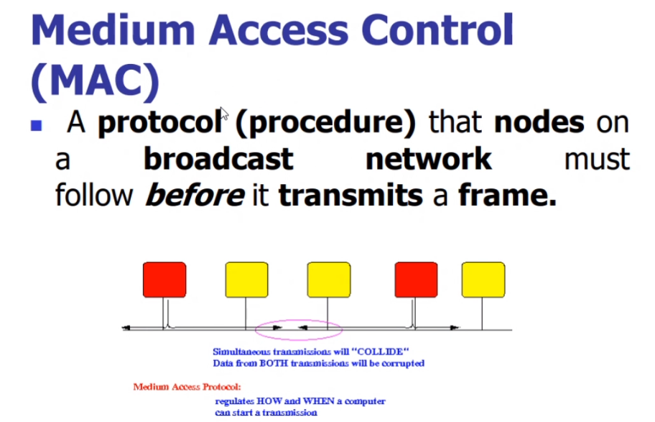

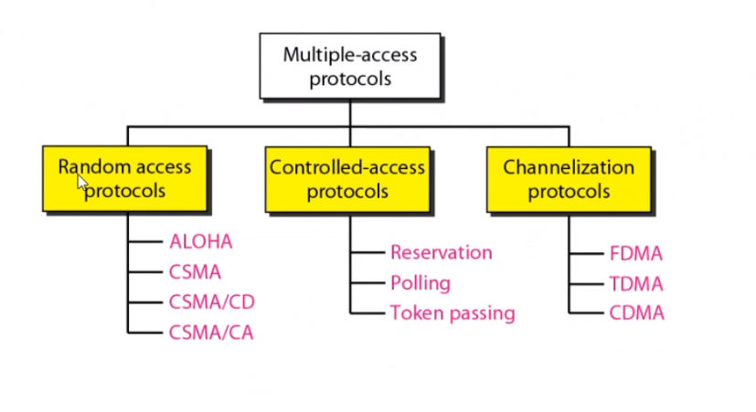

# **Random Access Protocol**

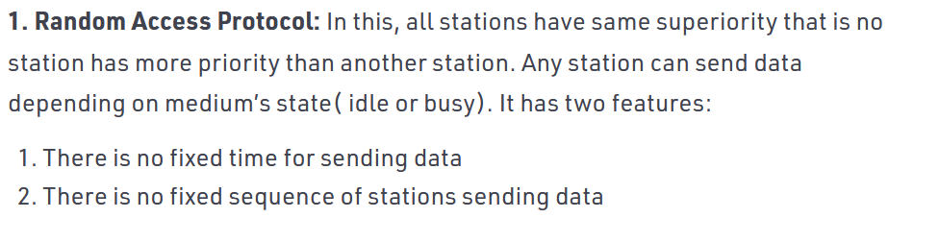

CD 🡪 Collision Detection   
CA 🡪 Collision Avoidance

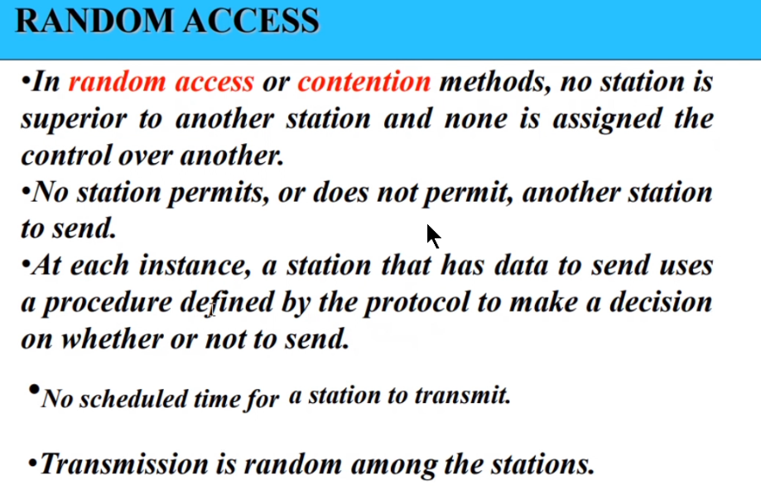

There is a competition between the stations to access the medium (contention)

# **ALOHA**

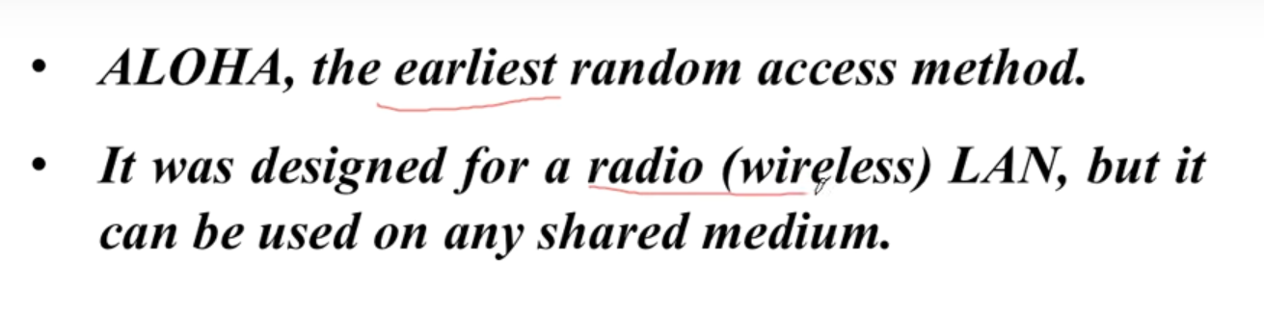

Can be used in both 🡪 wired and wireless medium

## **Pure ALOHA**

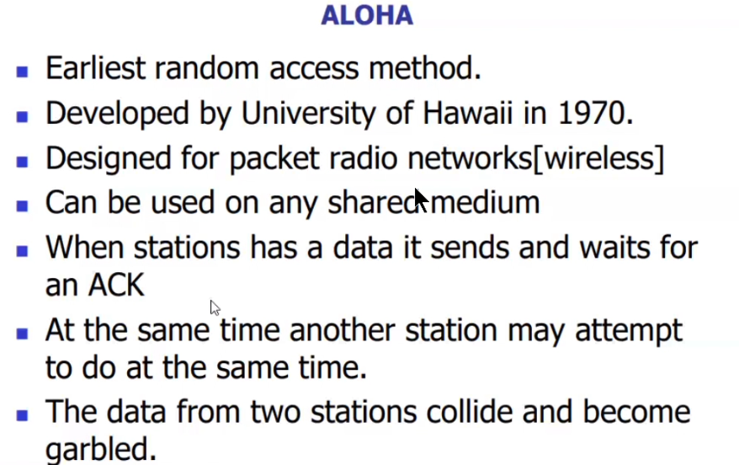

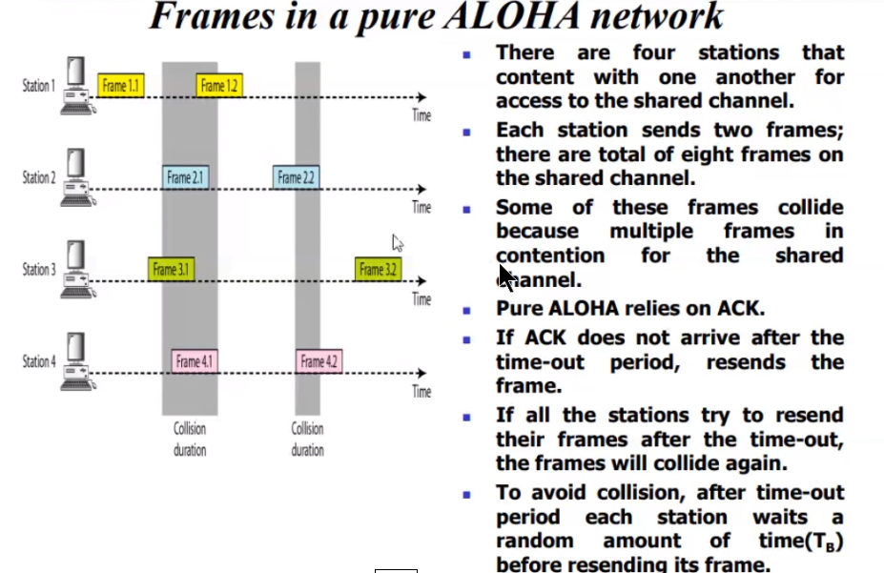



Frame 1.1 and Frame 3.2 have a better chance to reach the receiver without any collision.  
Out of 8 frames only 2 frames can go without any collision.

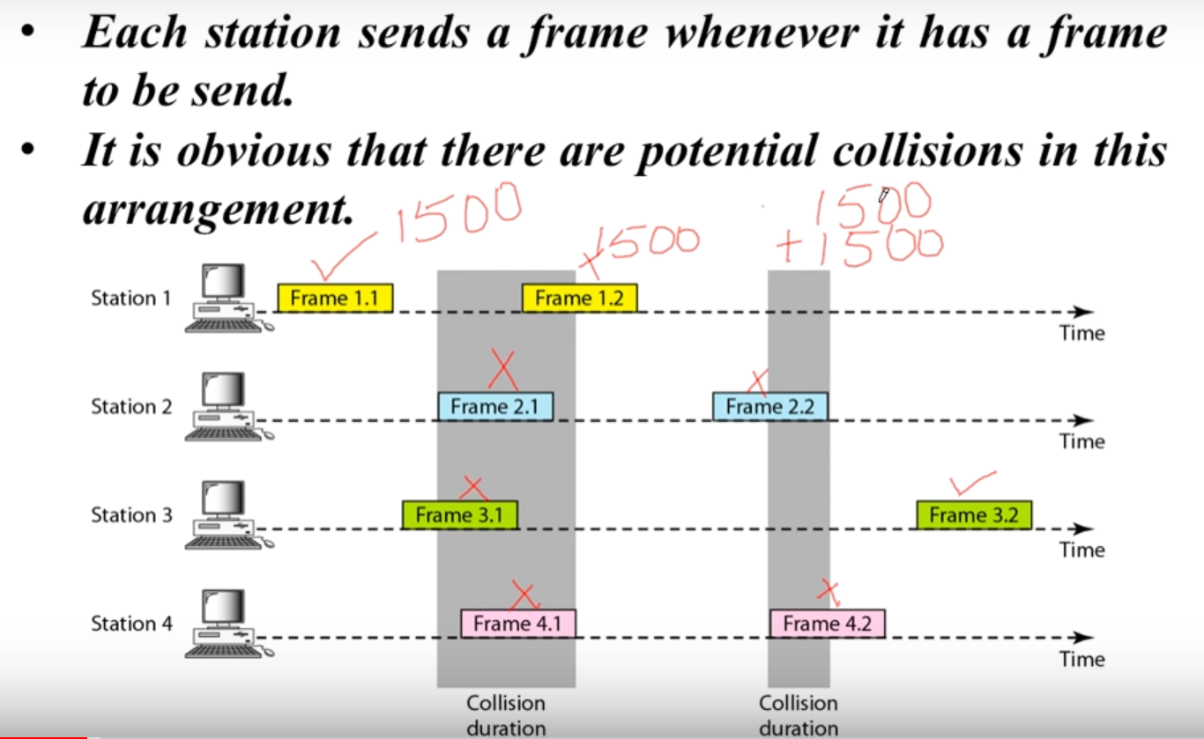

Frame 1.2 🡪 1500 bytes  
Sending and resending 🡪 3000 bytes [ Speed goes down ]

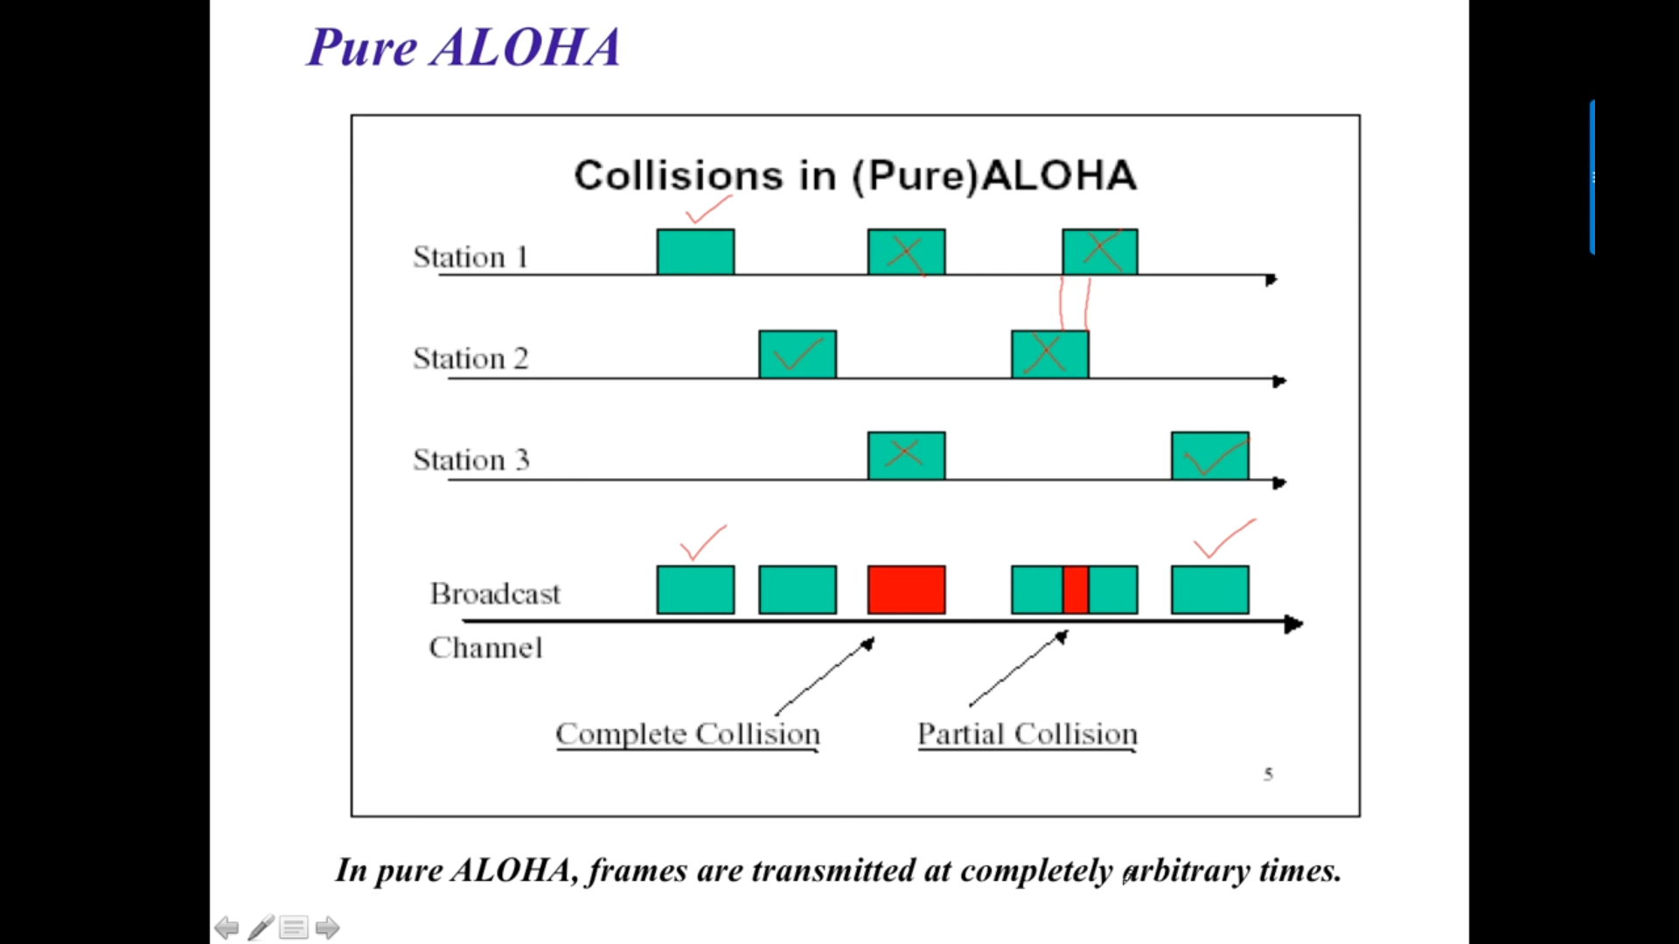

Even 1 bit of the frame collides with other frame, it will become a collision. The two frames have to be completely separate.

Randomness will help to avoid collision. By Manipulating the waiting period couple of frames can be ensured that it will be received by the receiver.

For eg: After deducting the collision, we can assign a random wait to all stations so that their frames may no collide further.

### **Procedure for Pure ALOHA**

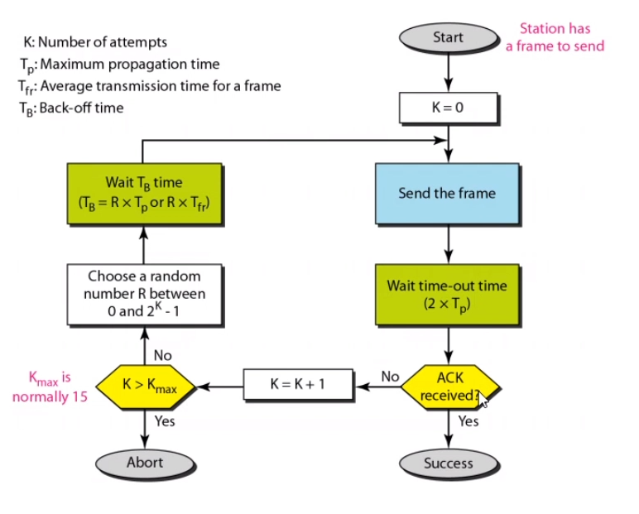

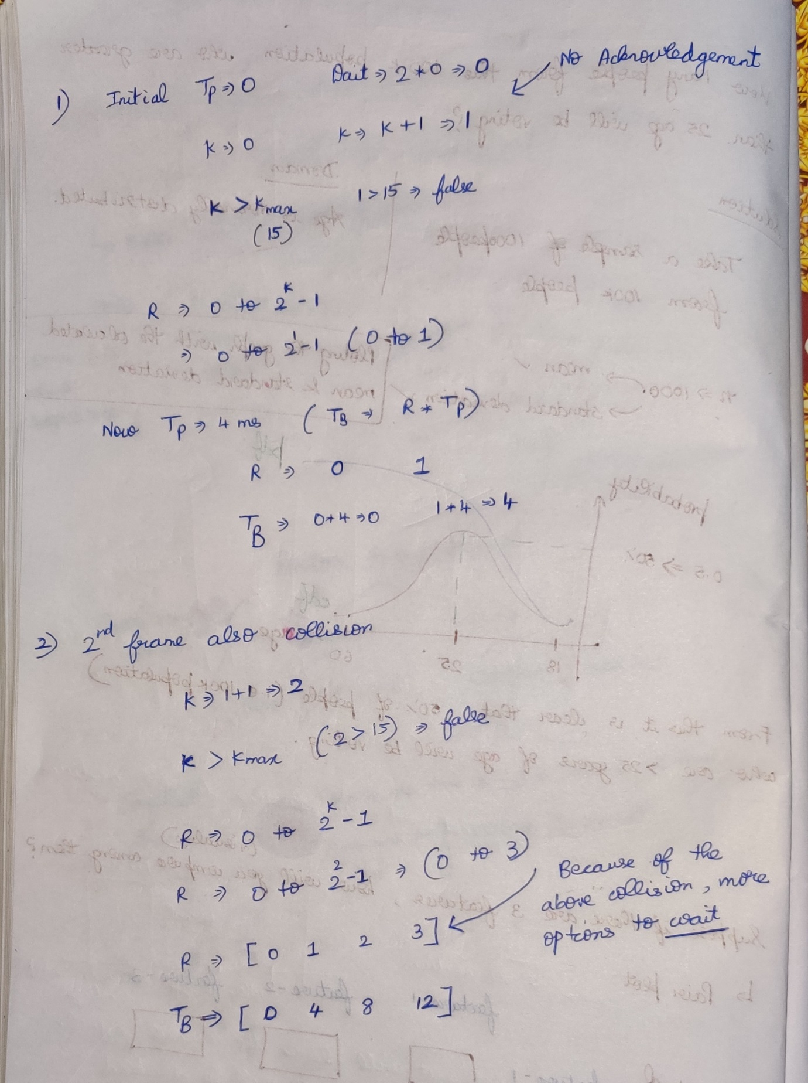

Why K is compared with certain maximum value????  
If there is no boundary function to K, infinitely this process goes on..

If there is no ACK, then definitely collision must took place, After collision set a random wait to every stations.

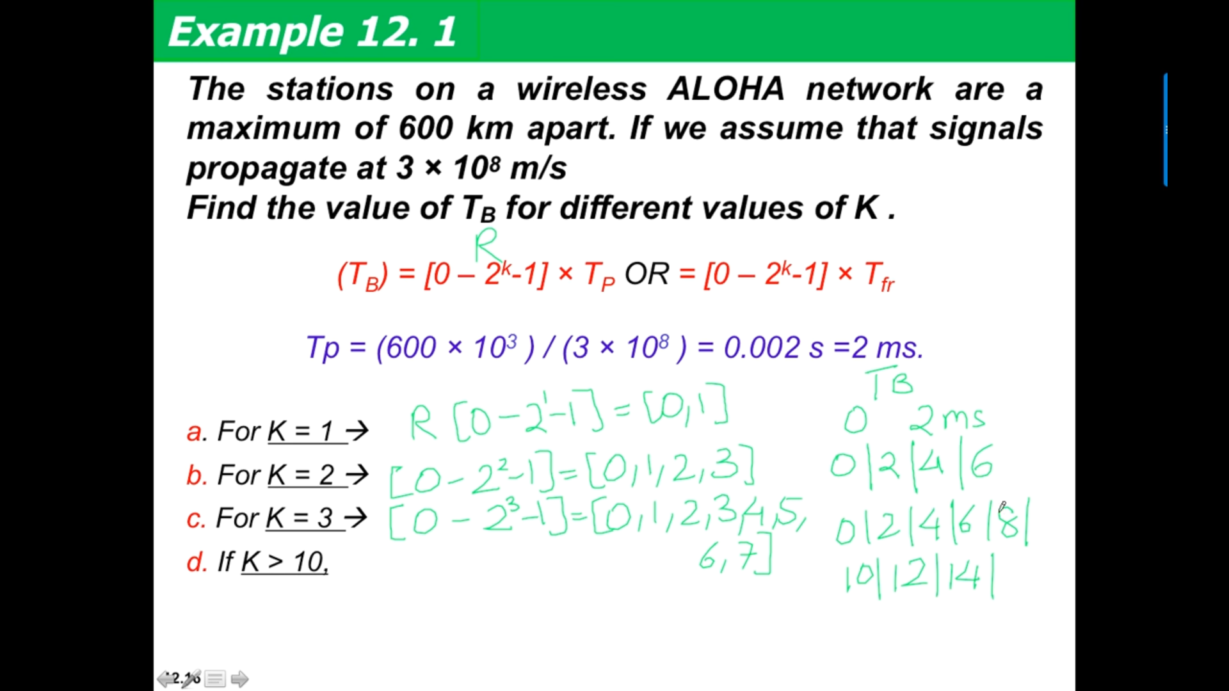

### **Random Access Protocol**

Yes, ALOHA falls under Random Access, any node in the network can transmit info at any time.

### **Is Acknowledgement there ???**

Yes, acknowledgement concept is there.   
If A sends an info to C, after C’s acknowledgement only A can able to send the next data.  
If C doesn’t acknowledge, then definitely due to collision C didn’t receive A’s data.  
The data from two stations collide with each-other.

### **Is it LAN based protocol??**

Yes.  
Only transmission time and No propagation time.

**The transmission delay** is the amount of time required for the router to push out the packet.

**The propagation delay**, is the time it takes a bit to propagate from one router to the next.

### **Maximum Propagation Delay**

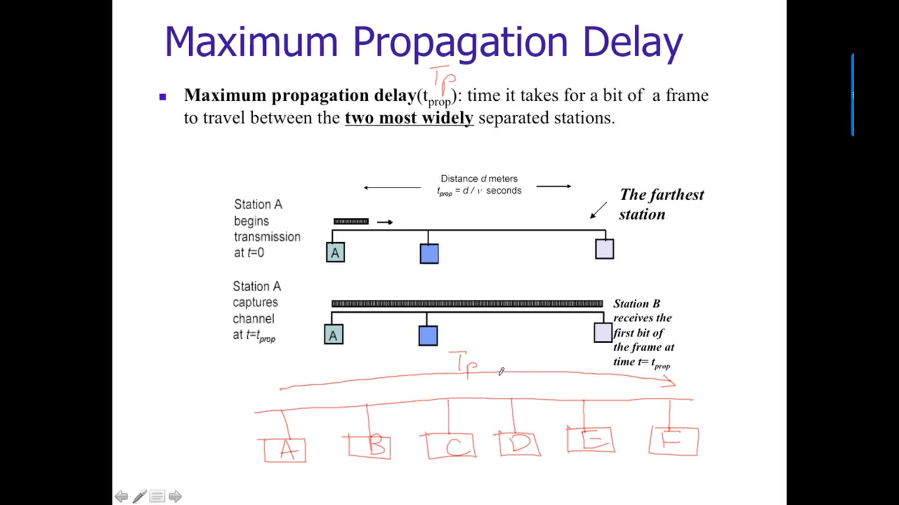

Eg: Tp 🡪 time taken for a packet in A’s station to reach station F

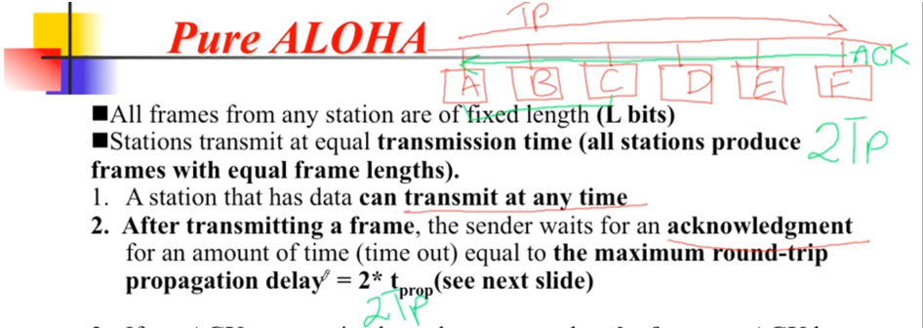

A to F and then F to A 🡪 2*Tp  
If A sends a packet to C and then receives an acknowledgement also, A will wait for 2*Tp.  
Not only for C, If A sends a packet to any station, A will wait for 2*Tp.

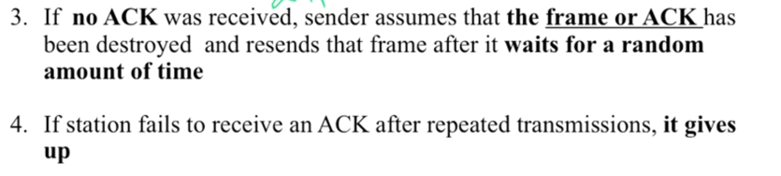

If within 2*Tp, A doesn’t receive any acknowledgement, A will understand that there is a collision and A will resend again after waiting for a random amount of time.  
A will wait 🡪 x amount of time  
B will wait 🡪 y amount of time  
C will wait 🡪 z amount of time

To avoid collision

### **Vulnerable Time**

Higher probability time for the collision to take place.

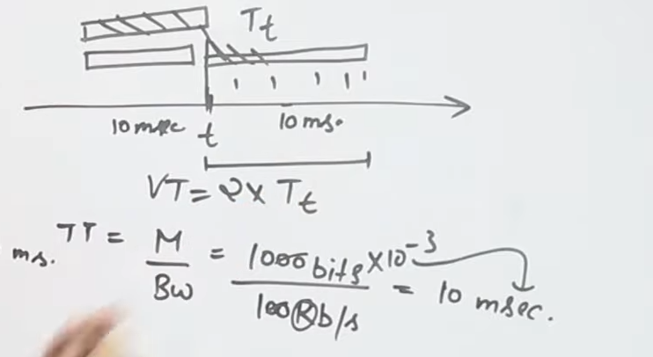

Transmission time 🡪 Message/ Bandwidth   
Vulnerable time 🡪 2 * Transmission time

If we know the vulnerable time, and if we stop other devise sending in this time we can avoid collision.

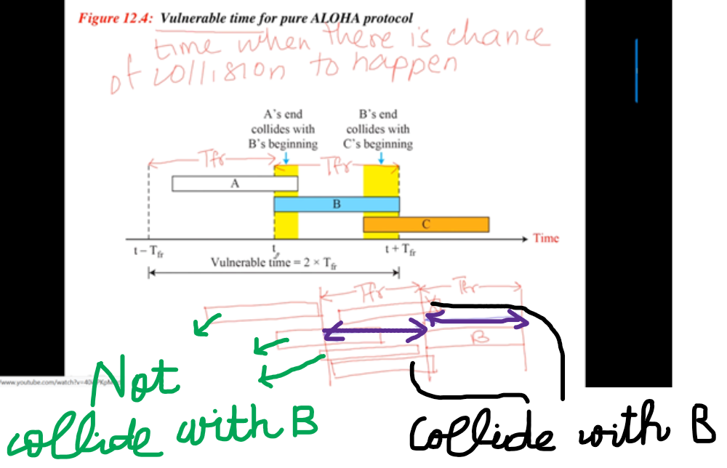

Frame B should not collide with any-other frame.

No frame should start transmitting in the vulnerable time region of B (**blue color).** To avoid collision with B the frames can start transmitting before/after the vulnerable time region of B.

In Pure-aloha for sending a single frame we need two slots. Then only no collision and high efficiency.

### **Throughput**

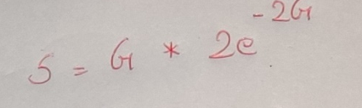

### **Efficiency**

2 comes from Vulnerable time formula.  
G 🡪 Number of stations who want to transmit the data.

### **Maximum efficiency for pure aloha**

G = ½ (i.e if half of the stations starts transmitting, the collisions will be minimum and the efficiency will be maximum.)  
Eg: 2 stations want to transmit, among the 2 if 1 starts transmit efficiency will be more.

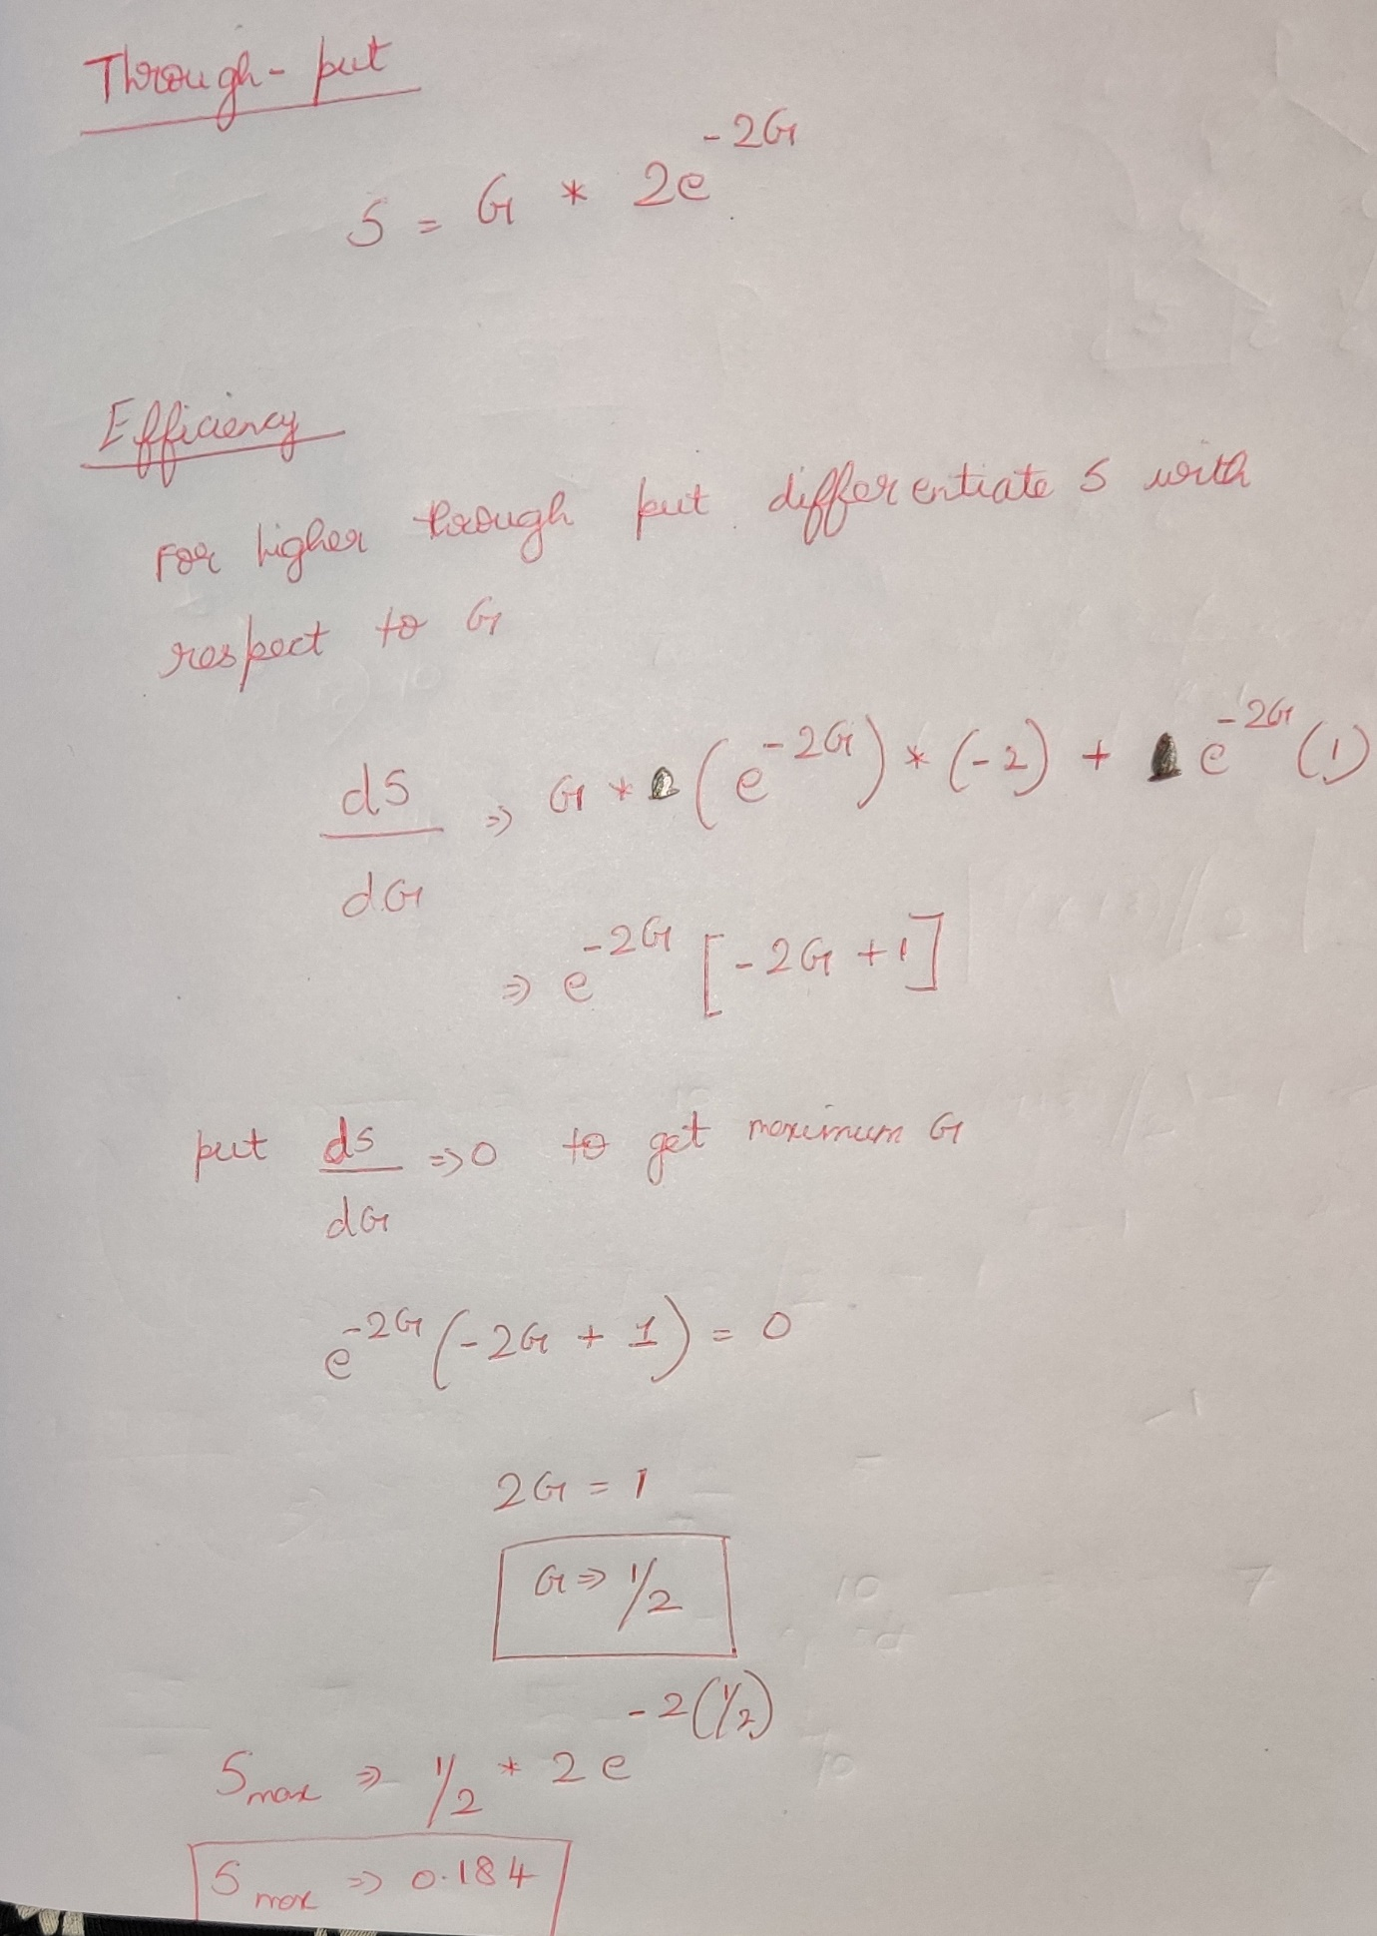

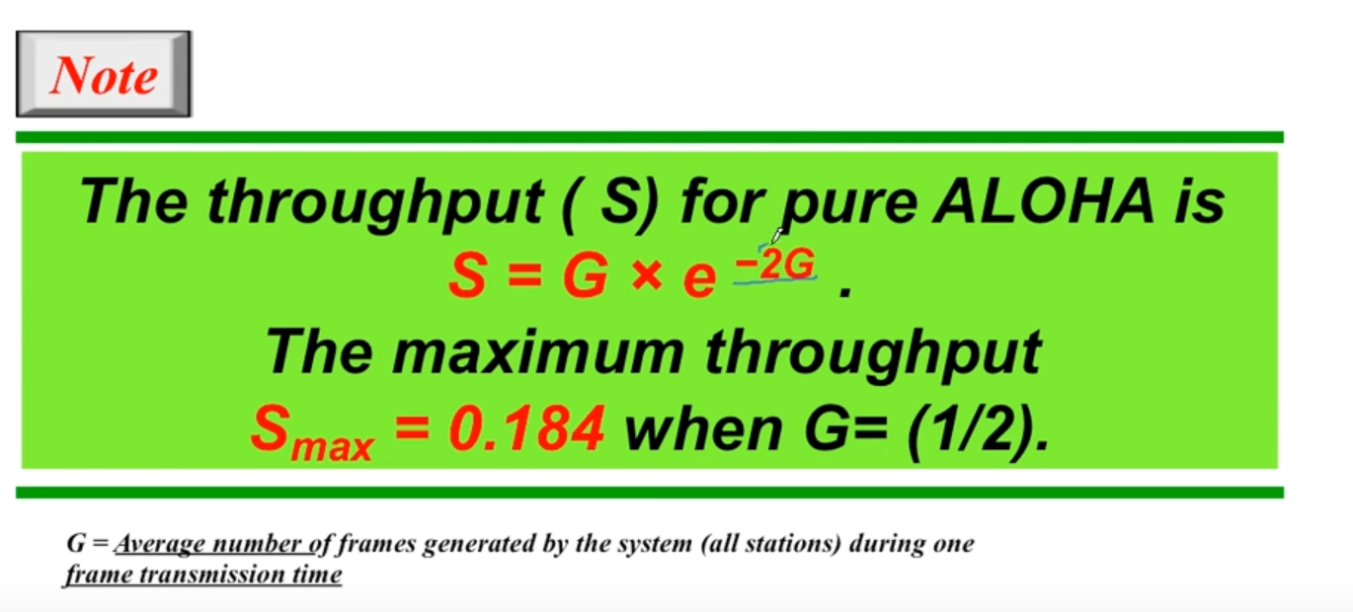

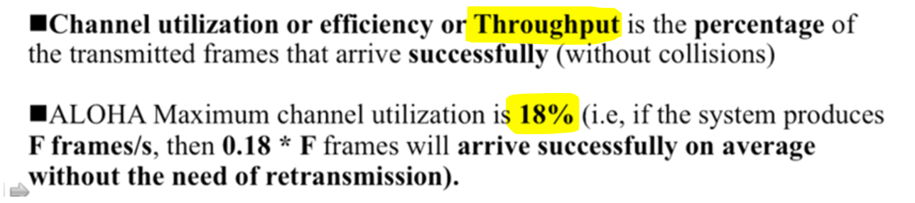

### **Final conclusions**

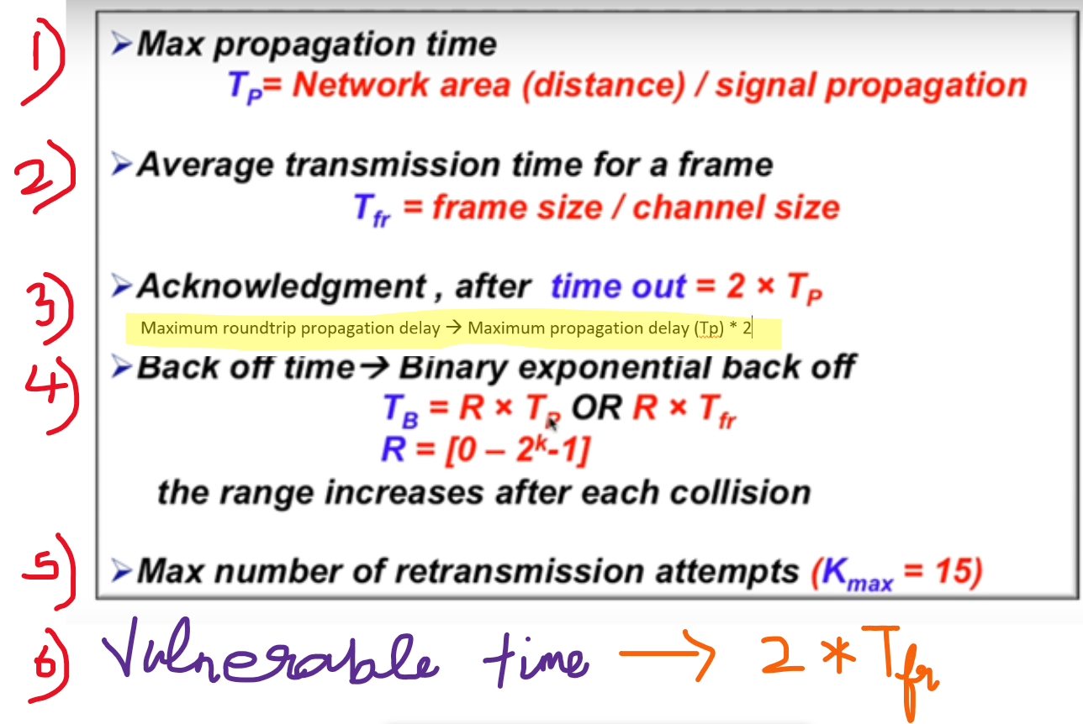

### **Problem questions**

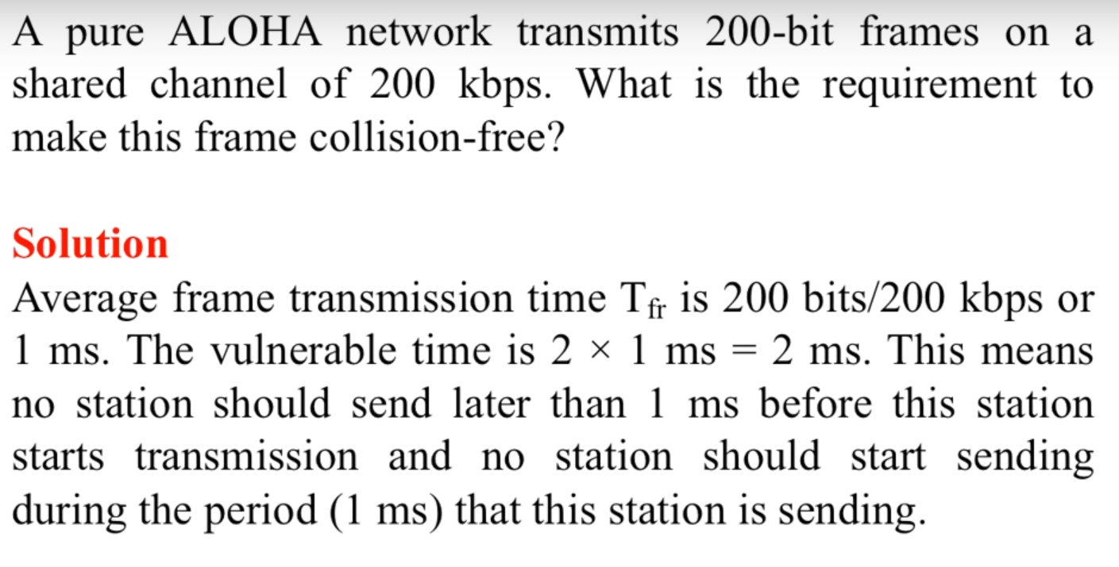  
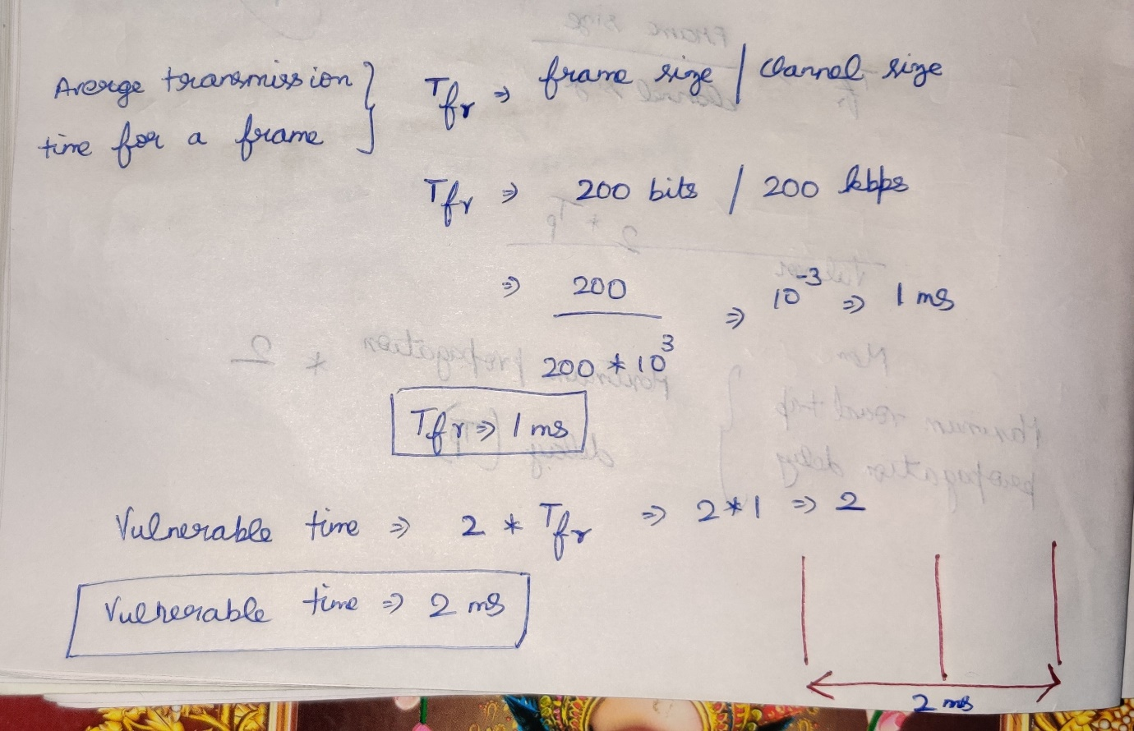

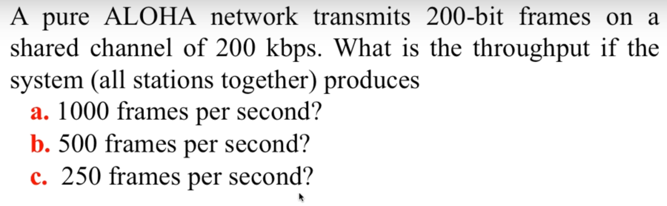

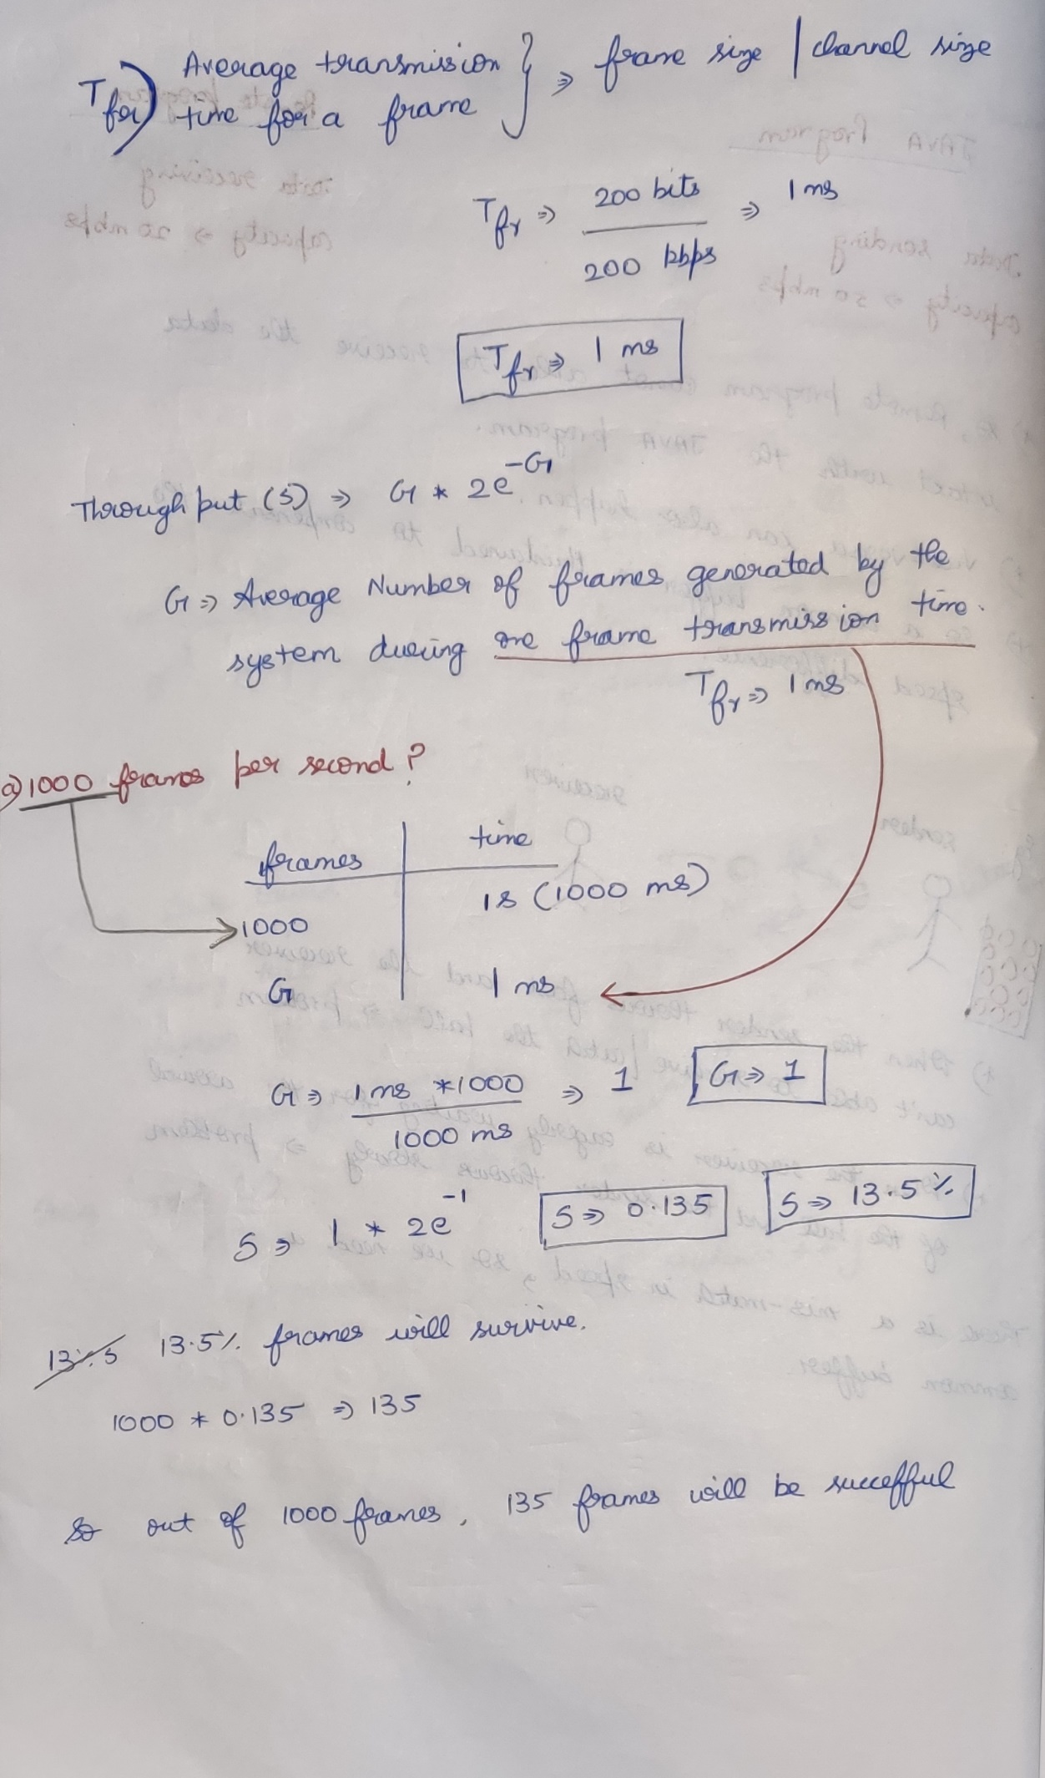

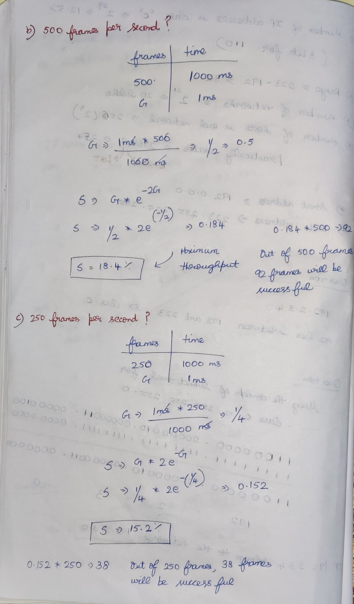

## **Slotted ALOHA**

In pure ALOHA, there is no systematic launch of frames.

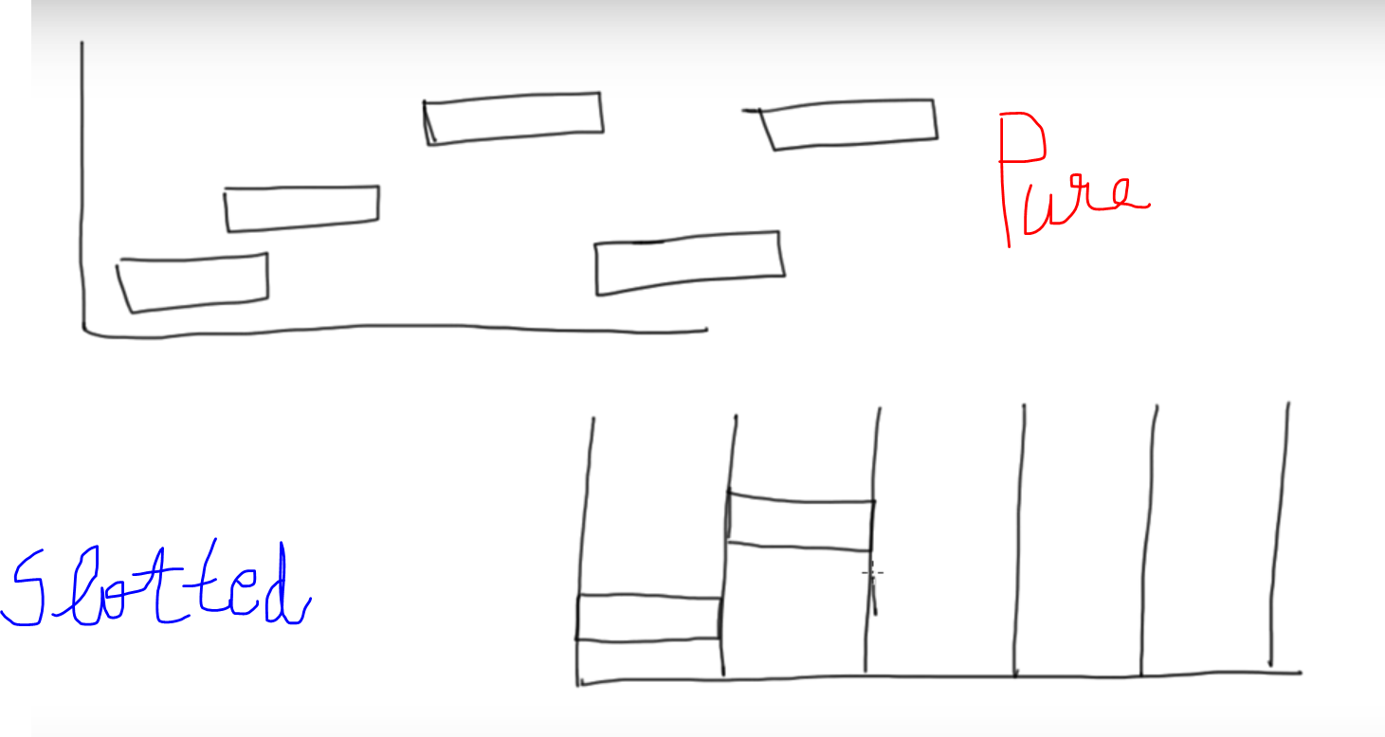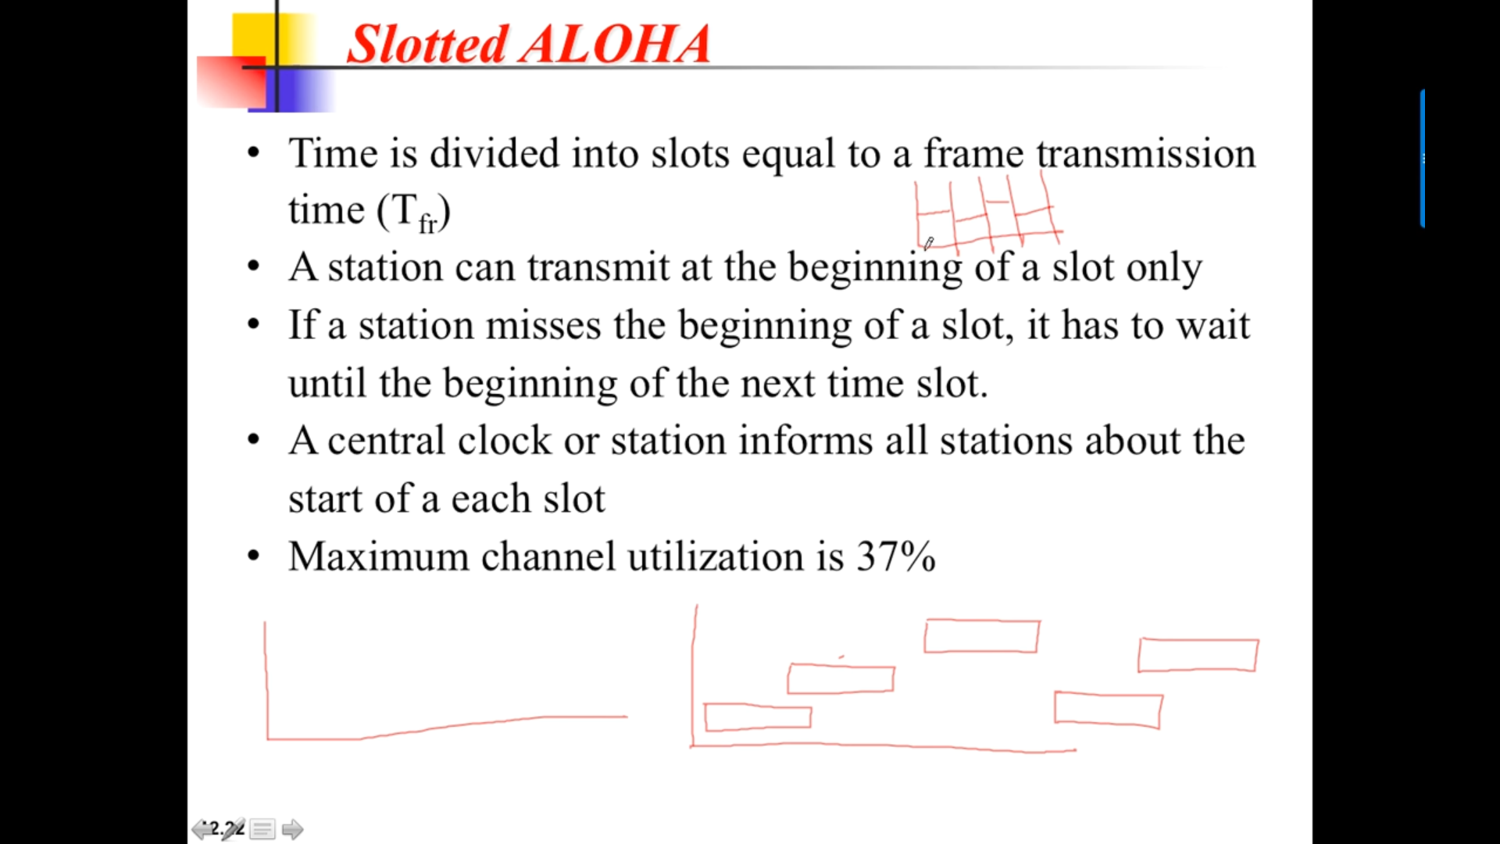

Transmission should happen only at the start of the slot.  
In slotted ALOHA if one slot is missed, then in the next slot only the frames can be sent.  
In slotted ALOHA there are no partial collision if a collision happens at one station, then that collision for the entire station frames at that slot.  
Central clock will provide the synchronization.

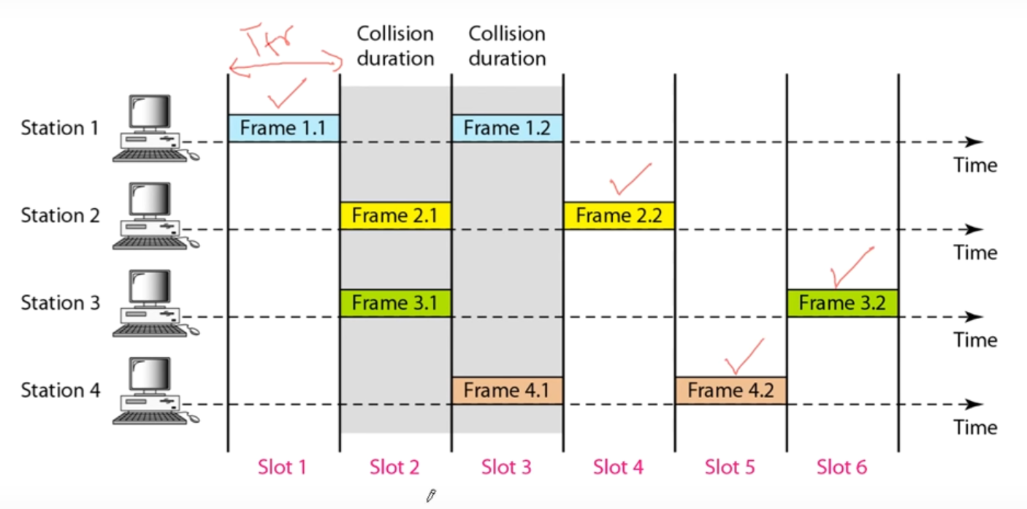

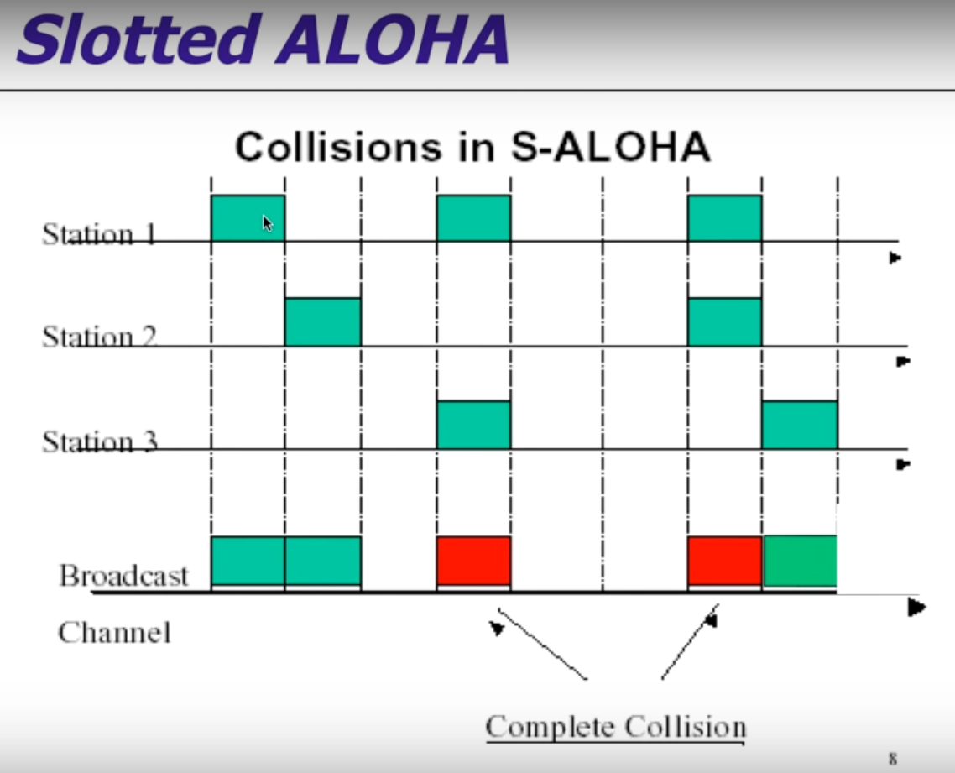

Pure ALOHA 🡪 Partial Collision  
Slotted ALOHA 🡪 Complete Collision

### **Vulnerable time**

Pure ALOHA 🡪 frame transmission takes only if 2 slots are free.  
Slotted ALOHA 🡪 frame transmission only at the beginning, so need of 2 slots.

There is no possibility of transmitting the frame in-between the slots.   
Only at the beginning of the slot the frames should transmit.

Chance of collision is not possible in Slotted ALOHA.

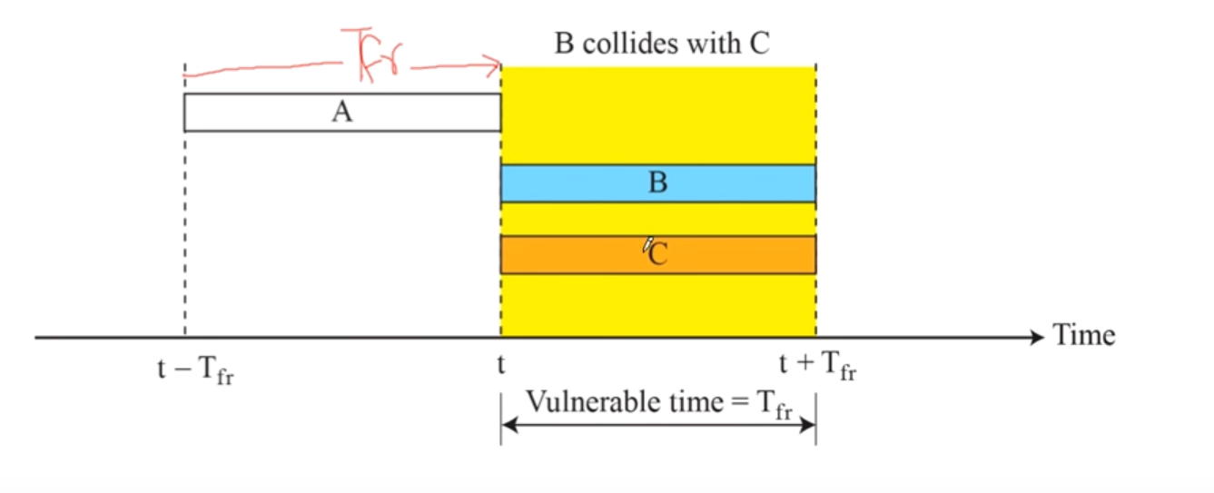

There is still a chance that frame-B and frame-C collides. But the collision will be in that particular slot only. 🡪 Complete Collision

### **Throughput**

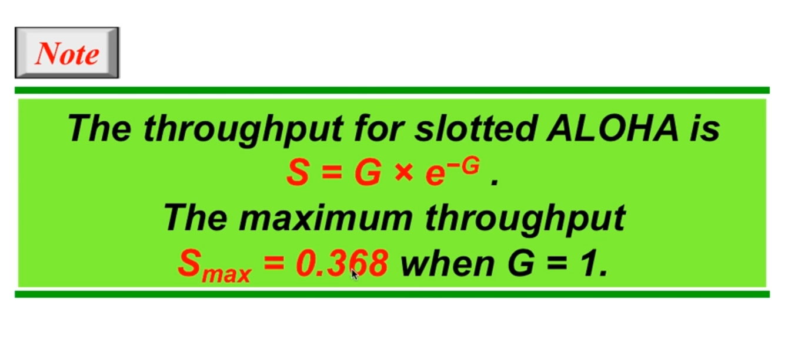

### **Problems**

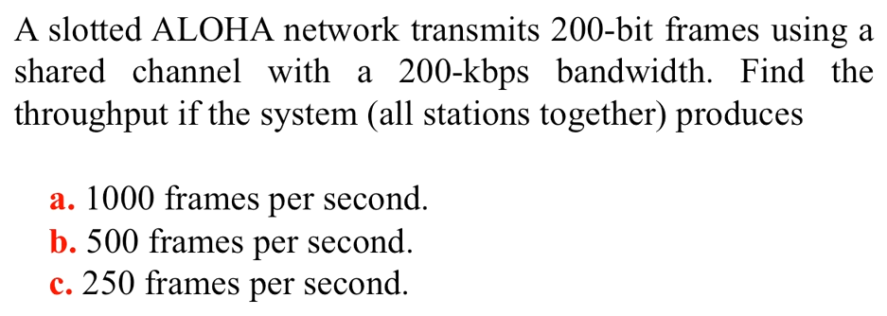

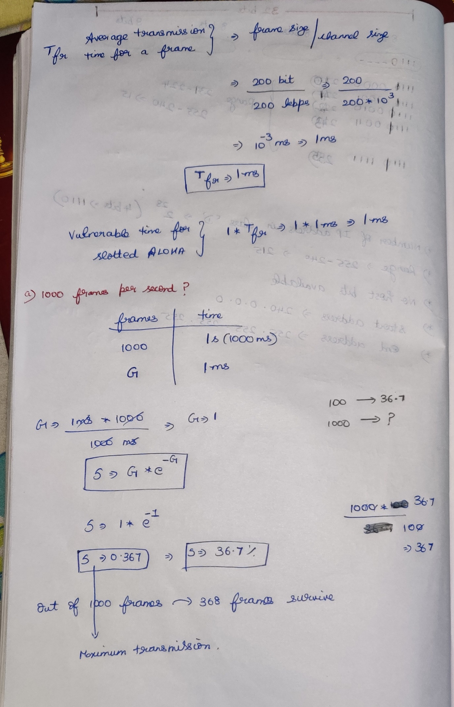

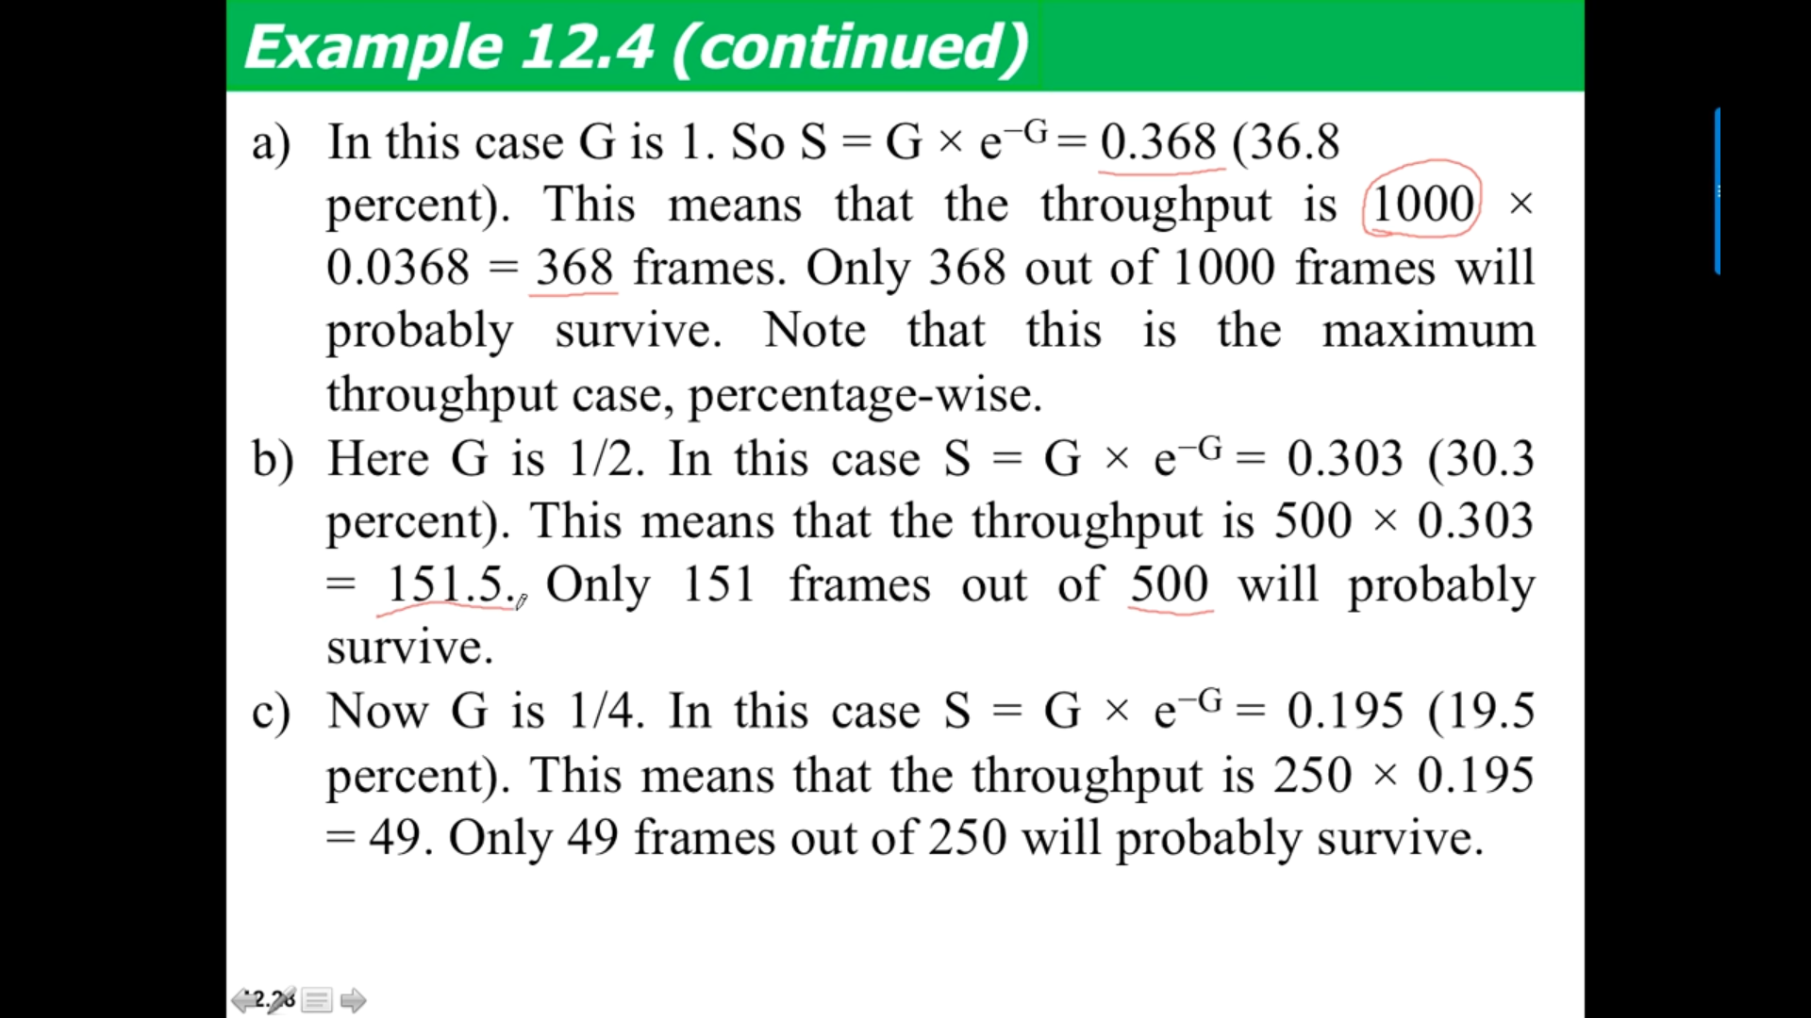

# **CSMA**

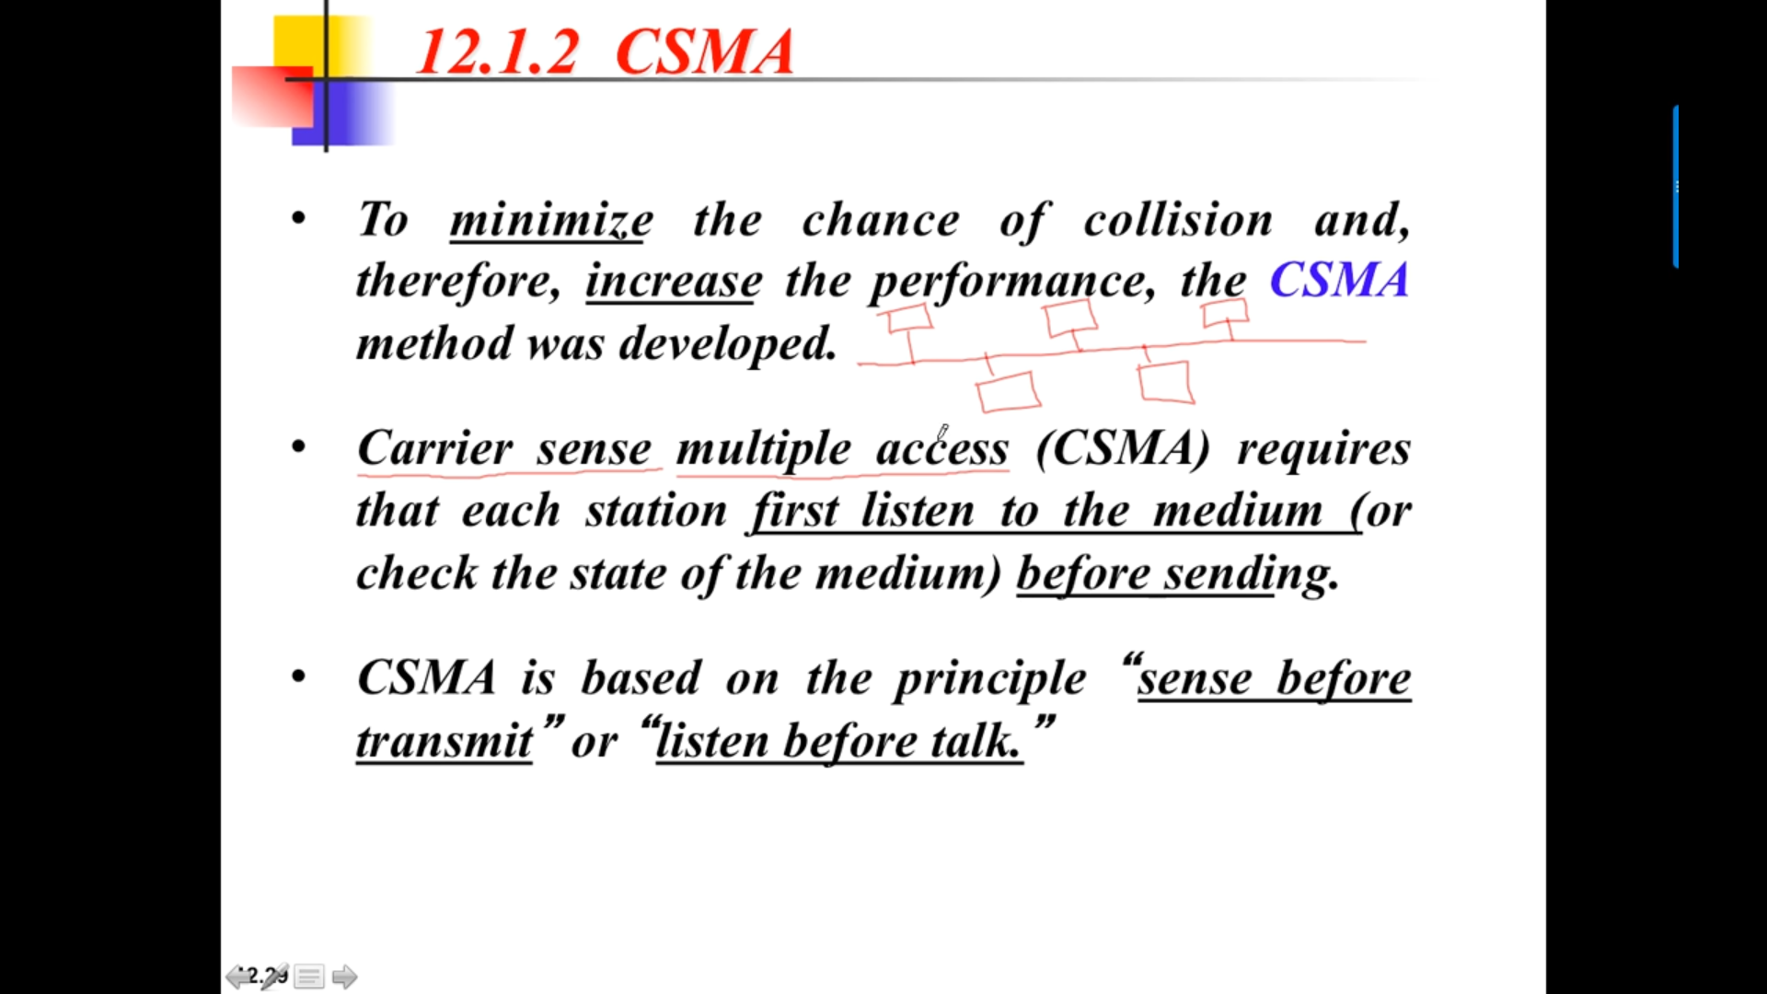



Eg: In a class-room, if the student wants to ask doubt to the faculty, the student will wait for a chance to ask the question. If the faculty stops, then the student will ask question.  
So first see when the medium is free, then only the station should start to transmit.

CSMA 🡪 Carrier Sense Multiple Access. Pure and slotted ALOHA will not care about the medium. It will keep on sending the frames and collision happens.   
Multiple Access 🡪 More than 1 device can access the medium.

**With respect to A**

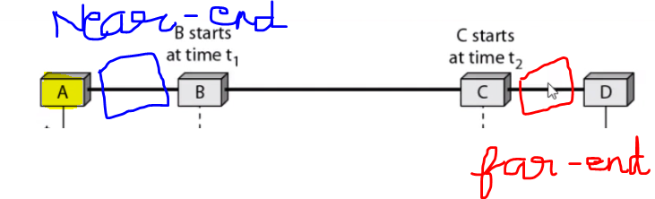

A and B communicating, after some time, collision can happen in between A and B. With respect to A and B 🡪 Nearer-end Collision. (A or B send the jamming signal to all the nodes. It is understood that collision had happened in the medium.

C and D communicating, after some time, collision can happen in between C and D. With respect to A and B 🡪 Far-end Collision. (C or D send the jamming signal to all the nodes. It is understood that collision had happened in the medium.

### **Space/time model of the collision in CSMA**

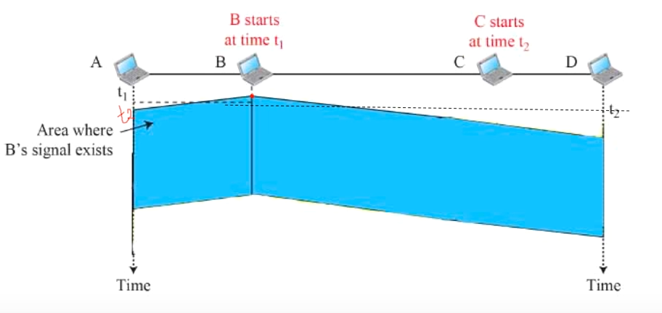

A will know about B’s signal at time t2. So all the station senses B’s signal, so all the stations will not send their signals.

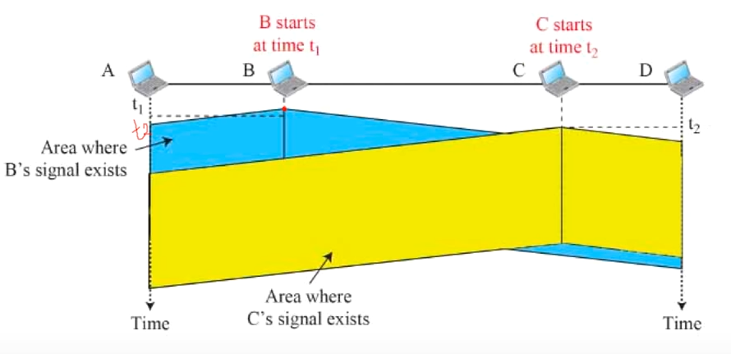

All the station senses C’s signal, so all the stations will not send their signals.

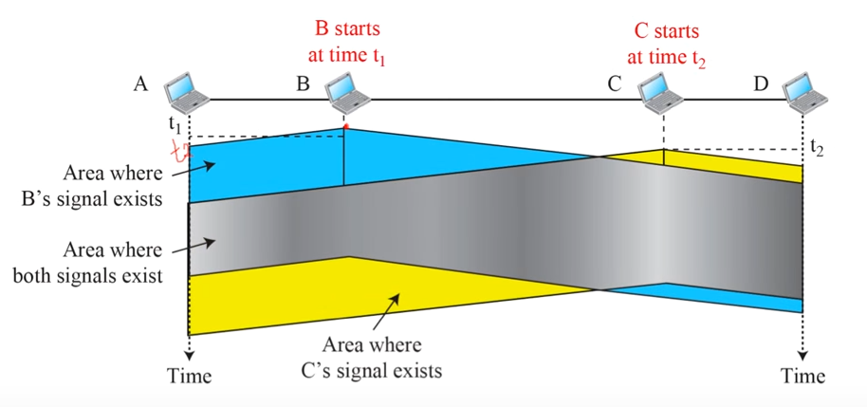

Both the signal meets together.

### **Vulnerable time**

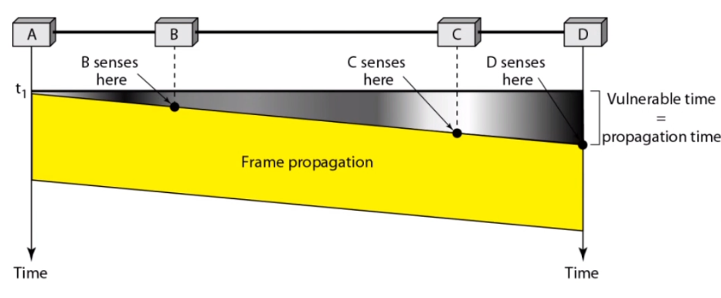

### **1-persistent**

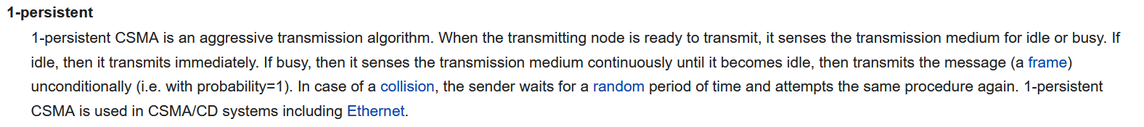  
Eg: Ethernet

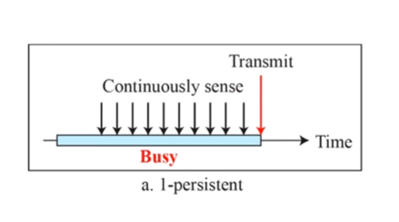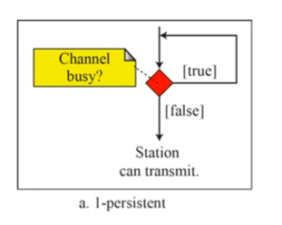

Channel busy 🡪 true (Keep on sensing)   
Channel busy 🡪 false (Immediately transmits)

### **0-persistent**

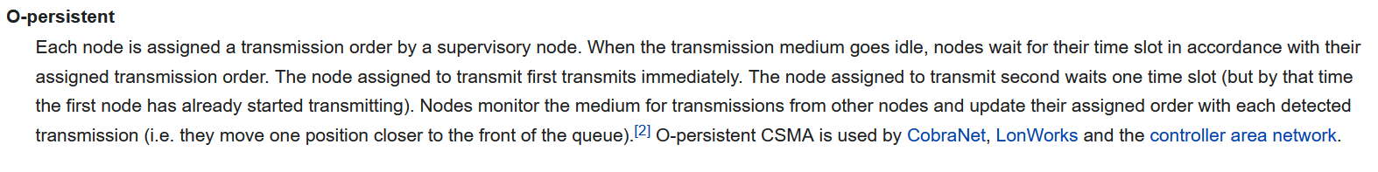  
Eg: CobraNet

### **Non-persistent**

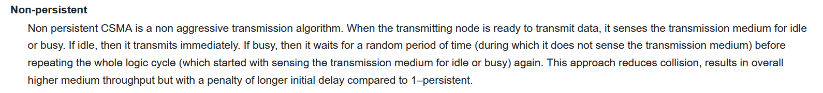

Waiting period is random.

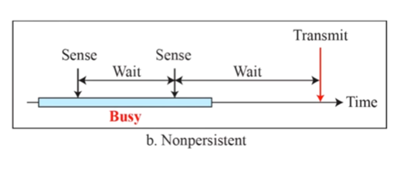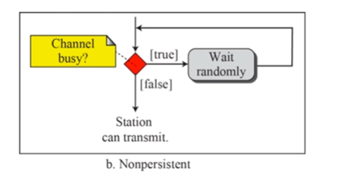

Channel busy 🡪 true (Keep on sensing) [ Wait for a random amount of time]  
Channel busy 🡪 false (Immediately transmits)

### **P-persistent**

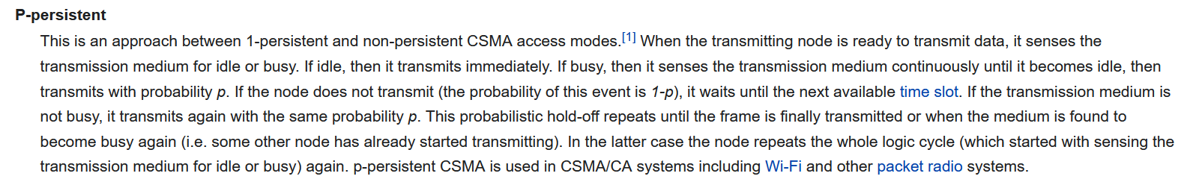

Initially If the medium is idle, then it transmits. If the medium is busy it waits. Once again if the medium becomes free, it will not transmit immediately, it will transmit with some probability(already assigned to that channel) which lies between 0 and 1.

Eg: Wifi signals.

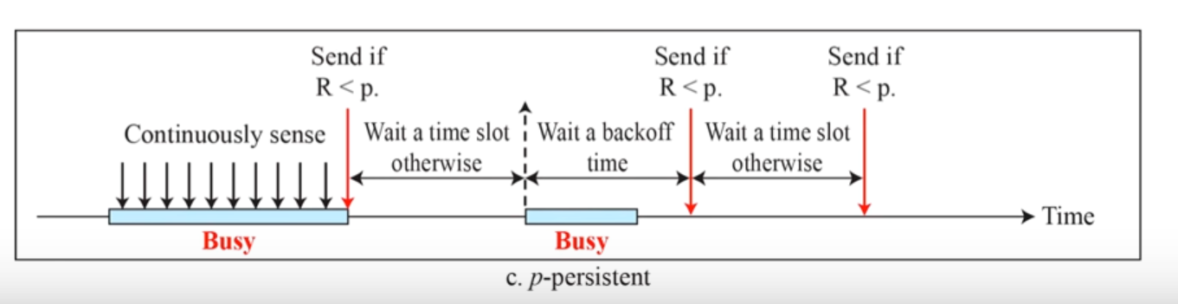

Waiting time is constant.

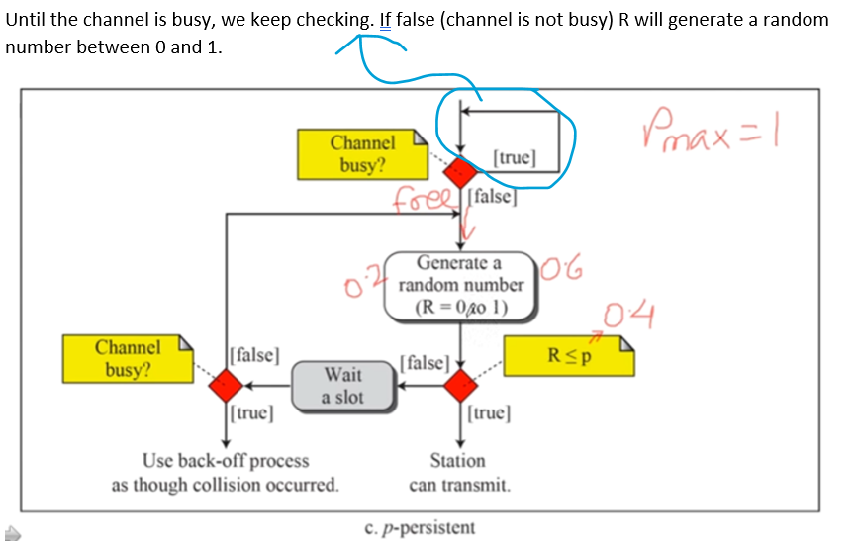 is free, due to large R that particular station cannot transmit.]  
Then waiting for a slot, After waiting if the channel is busy Use back-off process. If the channel is not busy once again generate a random number.

**Case-1:**   
0.4 🡪 probability already assigned to that channel.  
Now R = 0.2 (0.2<=0.4) 🡪 True So the station can transmit.

**Case-2:**Now R = 0.6 (0.6>=0.4) 🡪 Although the medium is free, but it will Wait for a time slot [ Before the medium is free (i.e while checking R<=p) but during waiting, there may be possibility that the another station can transmit (i.e busy medium) ] .  
So after waiting, it is necessary to check once again if the medium is free/not.  
If free 🡪 transmit   
Else once again Generate random number, compare , ……

### **CSMA/CD**

Carrier Sense Multiple Access with Collision Detection.

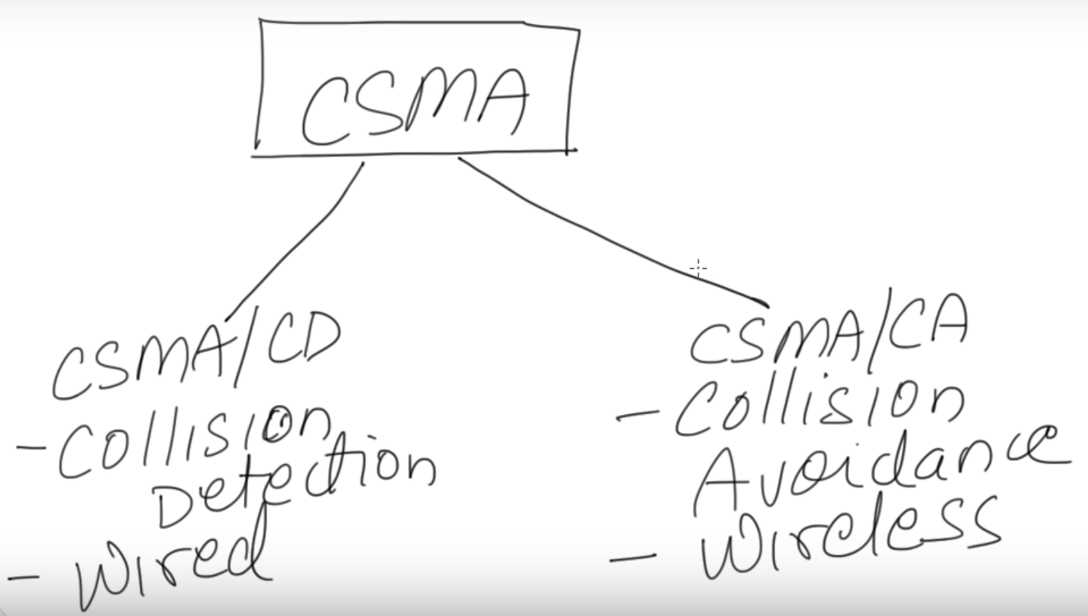

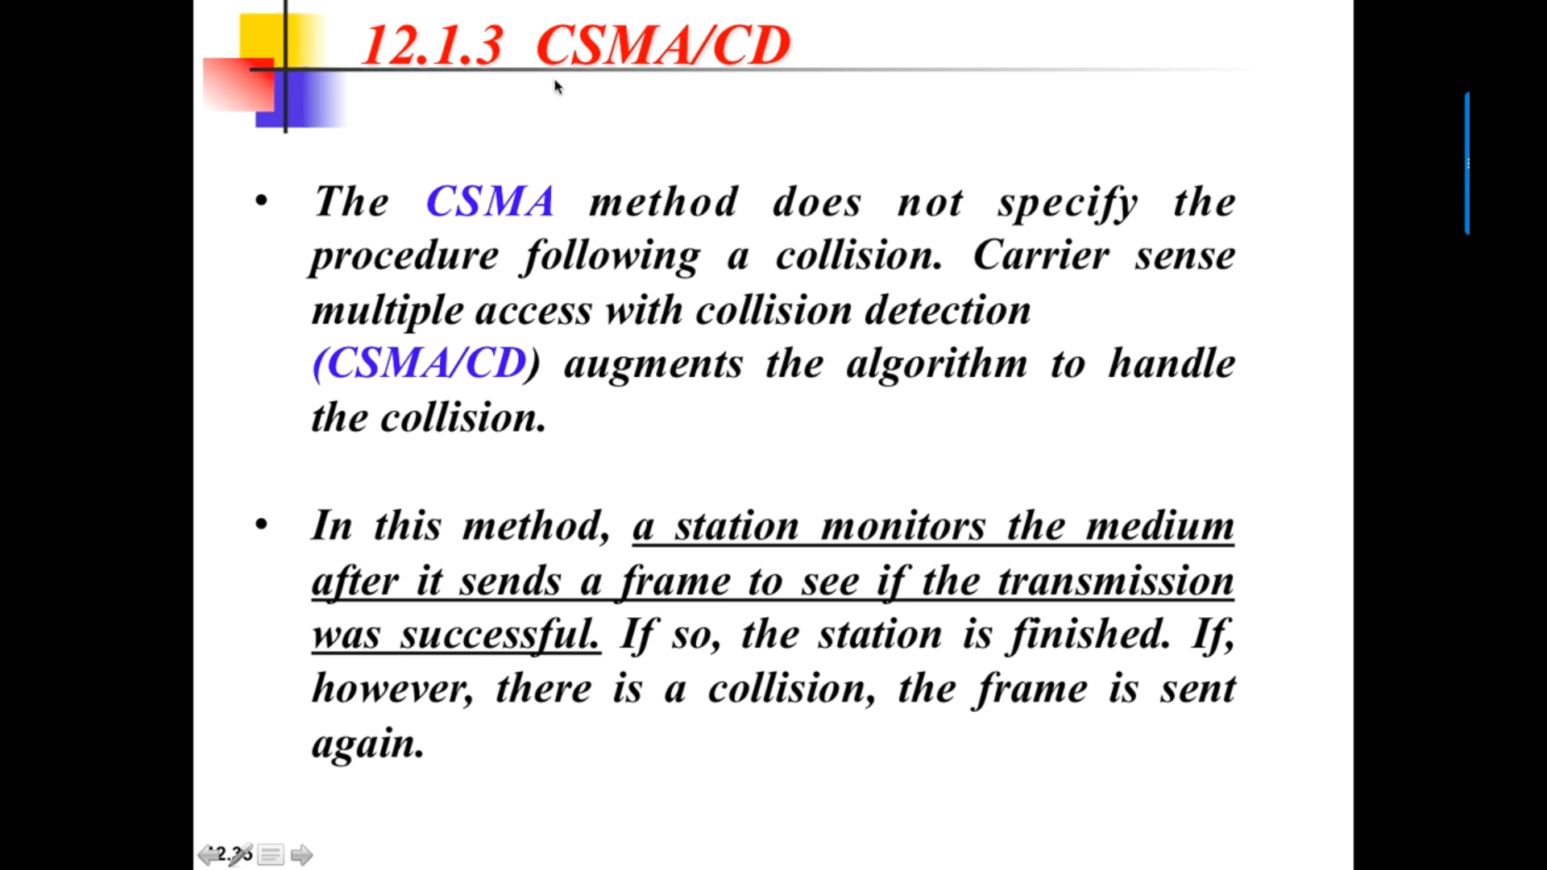

No acknowledgement system.

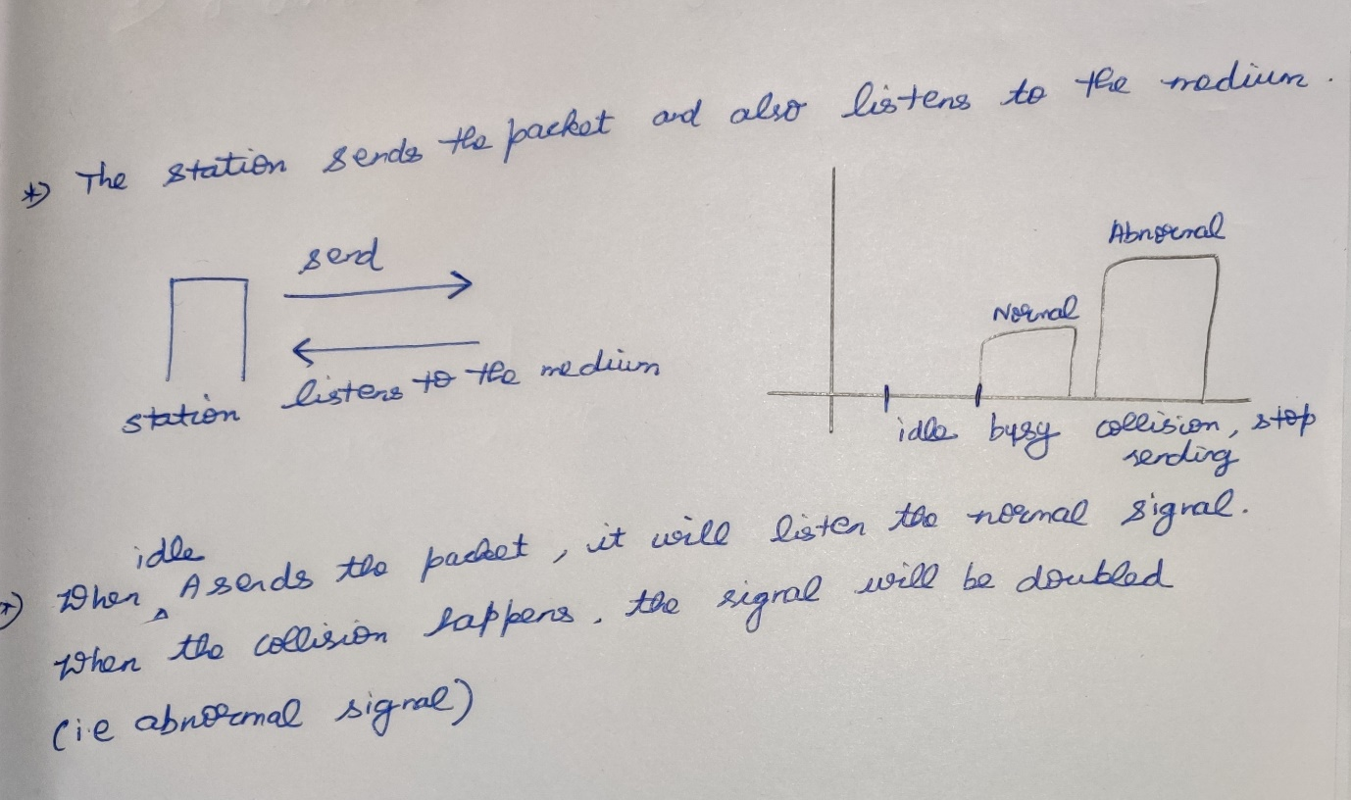

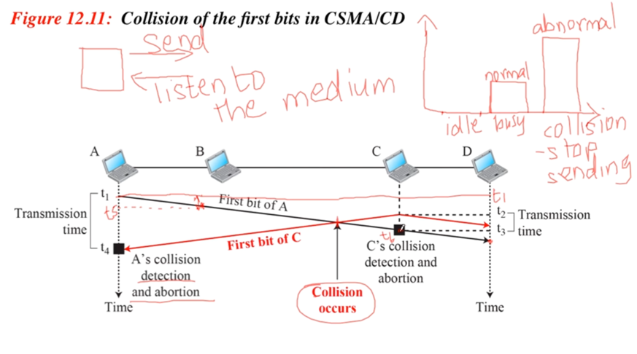

At time t1 A sends the packet.  
At time t5, the A’s first bit reached B. (Now only B knows that A is sending a packet in the medium).  
D 🡪 farthest station.  
At time t2, C station sends the packet un-aware that A’s packet is on the way.  
Collision occurs 🡪 A’s energy + C’s energy = so the signal is abnormal.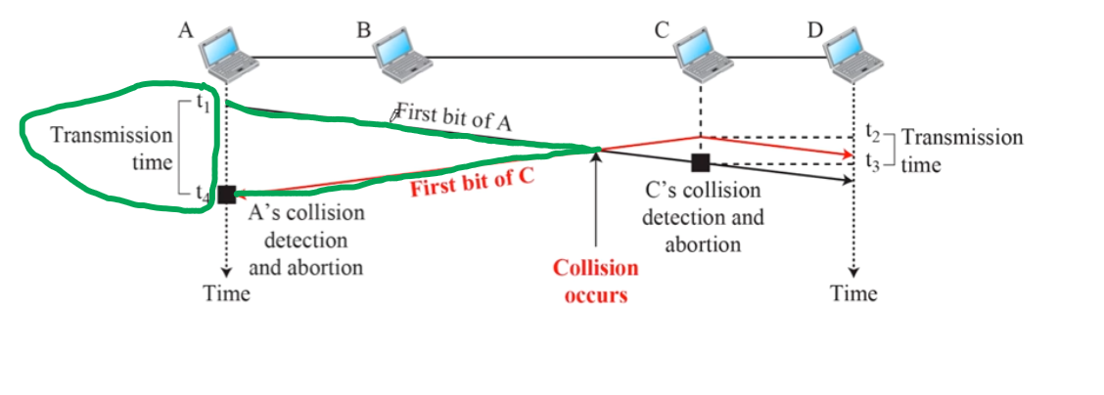  
After collision Jammer signal will be sent back to A and it reaches at t4.   
Then A will detect the collision and stop the transmission.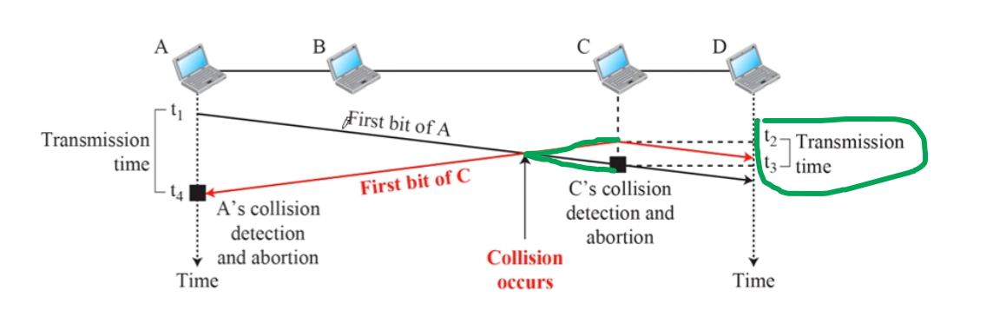  
After collision Jammer signal will be sent back to C and it reaches at t6.  
Then C will detect the collision and stop the transmission.

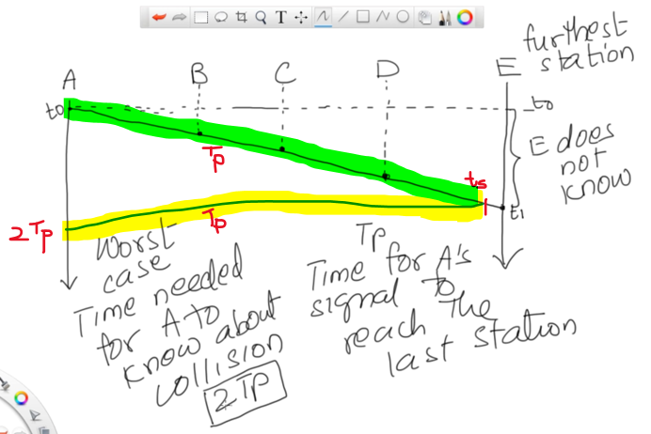

From t0 to t1, E doesn’t know that A is sending. In all this time there can be a chance of E sending and collision takes place.

Tp (t0-t1 propagation delay) 🡪 Time for A’s signal to reach the last station E. In Worst case scenario, A signal will be collided with E just before t1 (i.e ts) and returns back.   
Approximately it will take 2*Tp for ( one Tp 🡪 sending and another Tp 🡪 the jammer signal to reach back A)

Maximum time taken by a station to detect the collision 🡪 2*Tp (Tp is Transmission time)

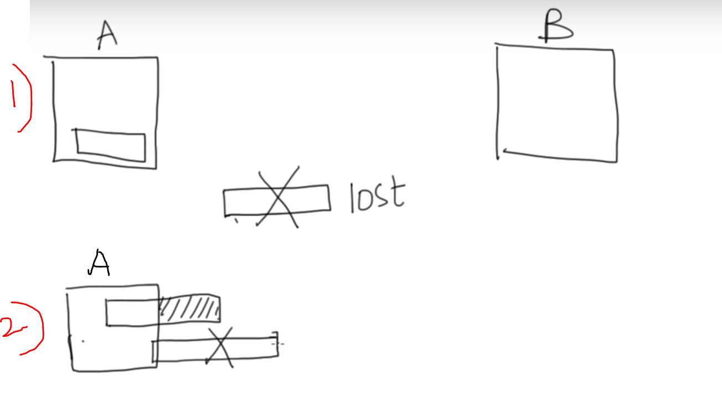

Case-1 : Initially there may be chance that A’s packet will be lost in the middle, since there is no mechanism of acknowledgement in CSMA CD.

Case-2 :If the packet leaves the A station partially, and in any part of the packet if the collision happens A will send the packet once again.

#### **Flow Diagram**

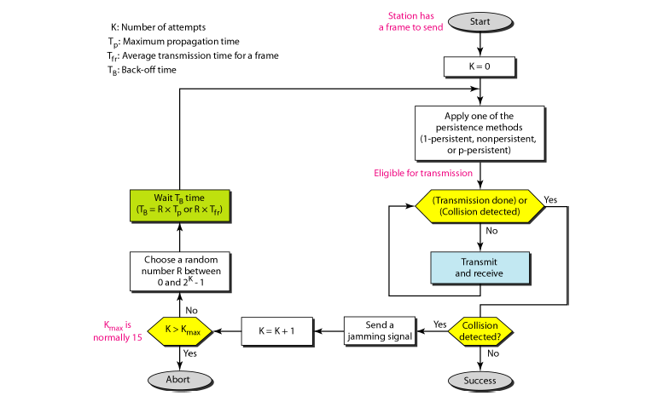



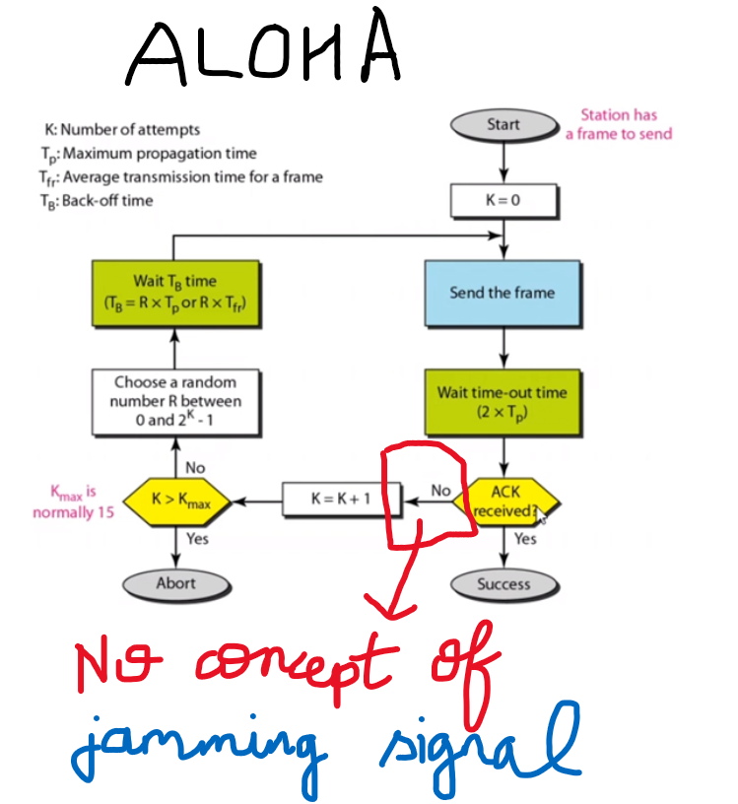

Apply any of the persistent method (0,1 persistent , p persistent etc)  
receive 🡪listening to the medium.  
If collision occurred, jamming signal is sent to all the station in the entire medium.

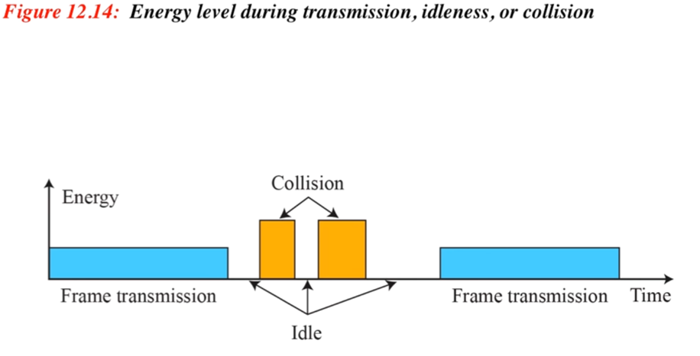

During collision the signal will become doubled.  
During transmission the signal will be flattened since there is no collision.

### **CSMA/CA**

Carrier Sense Multiple Access with Collision Avoidance.

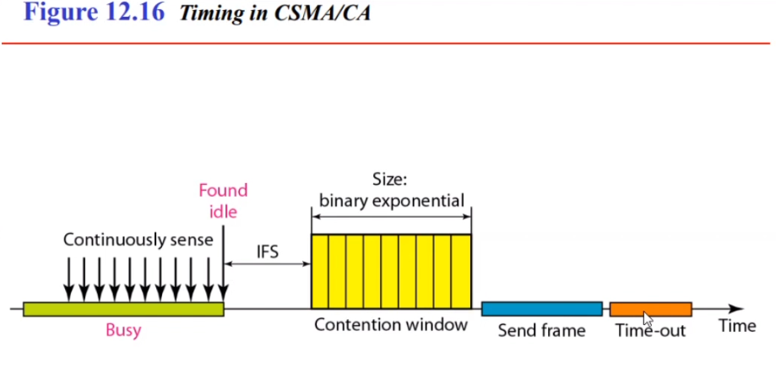

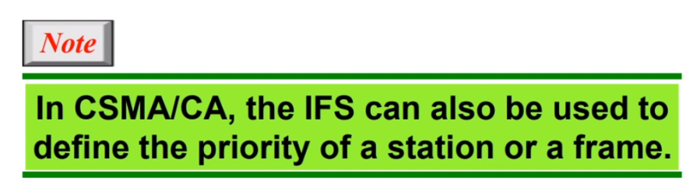

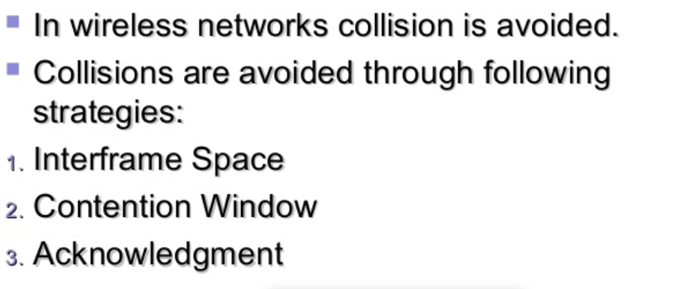

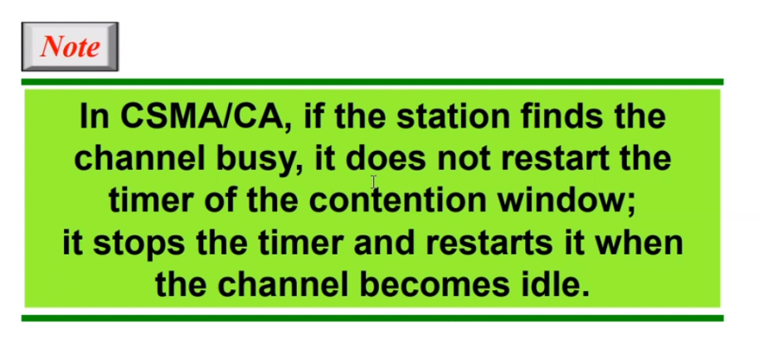

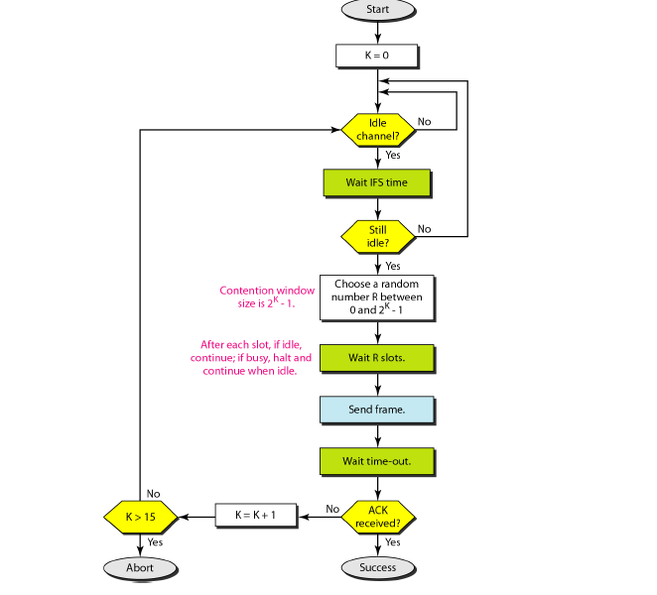

# **Controlled-Access Protocol**

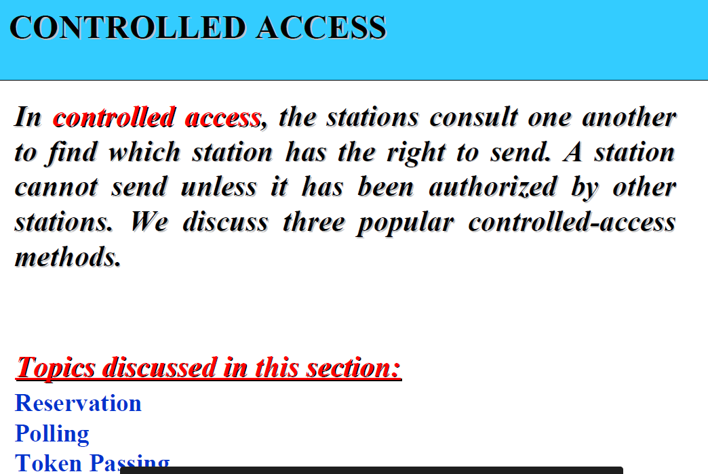

## **Reservation**

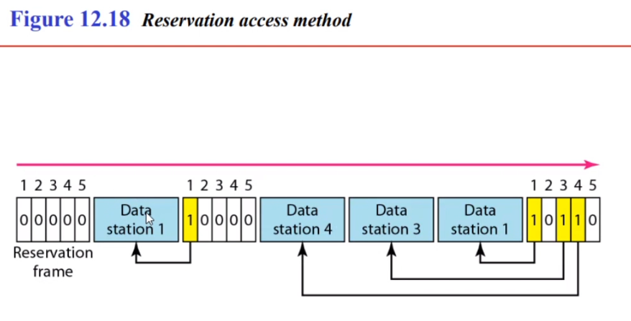

## **Polling**

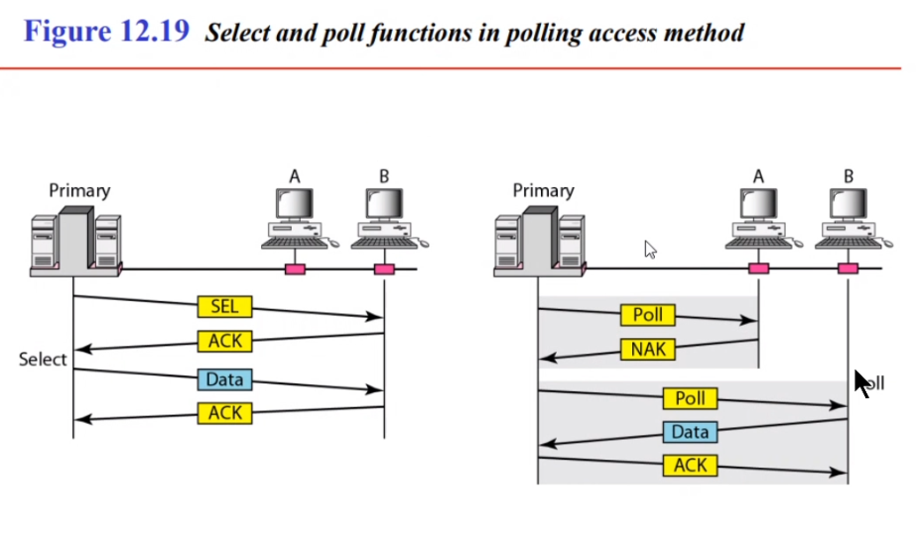

## **Token Passing**

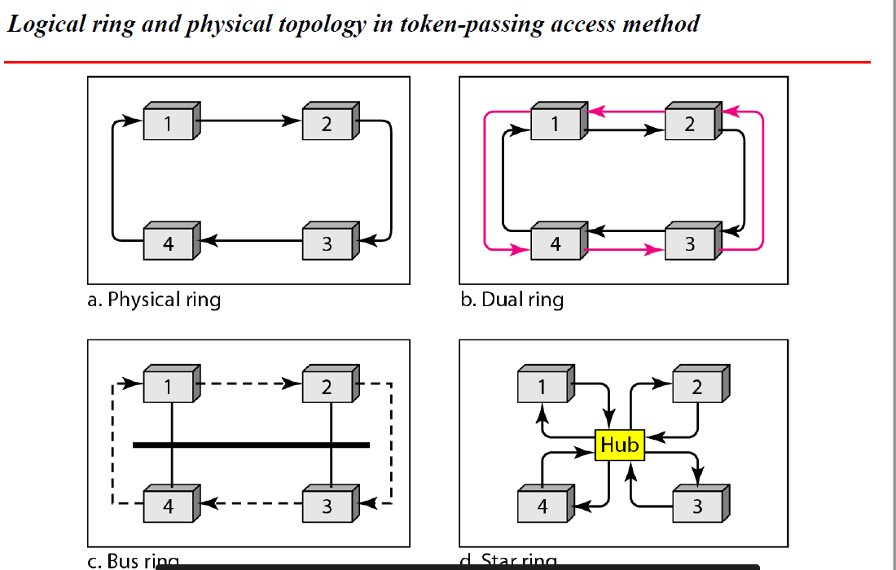

# **Channelization Protocol**

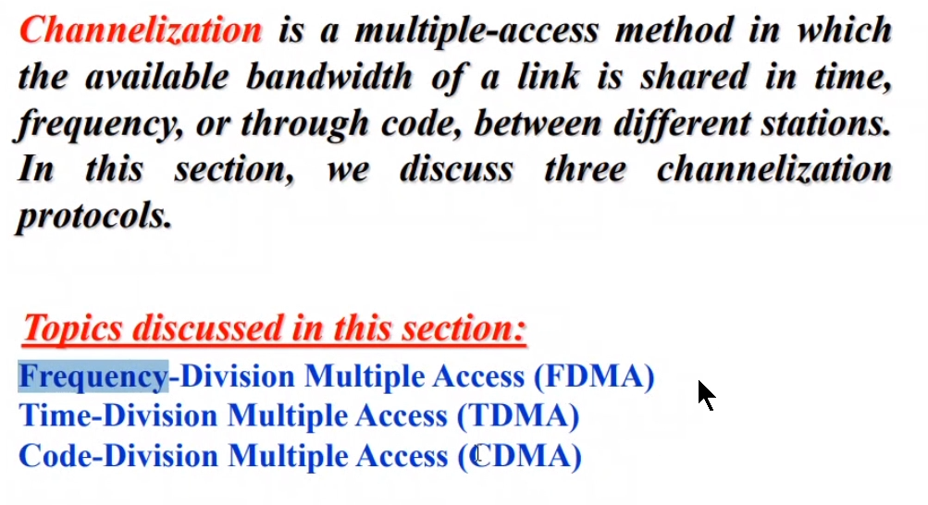

## **FDMA**

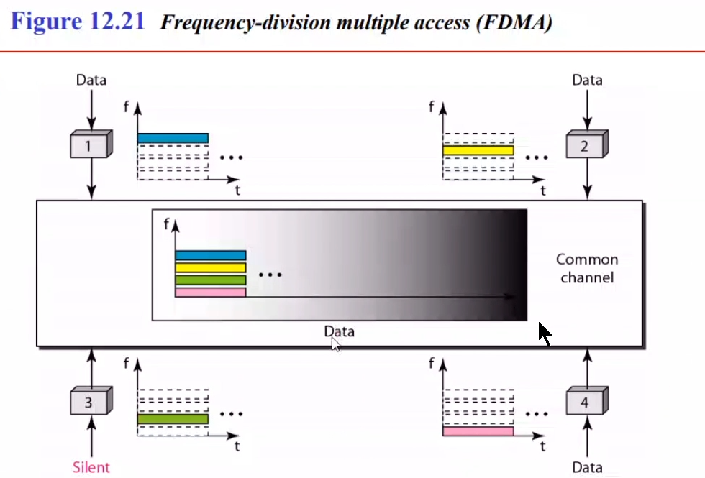

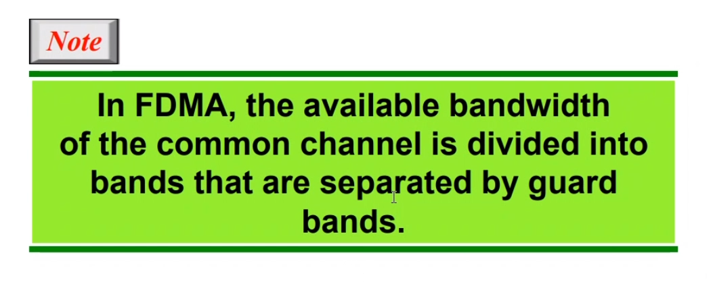

## **TDMA**

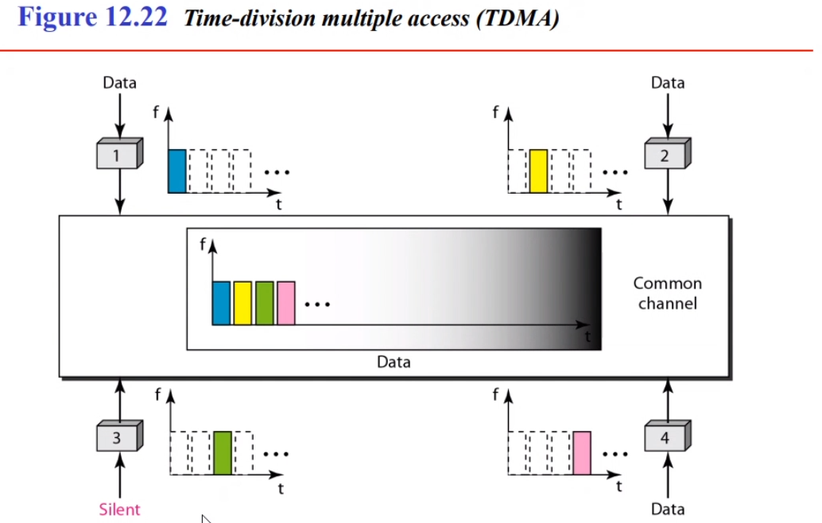

## **CDMA**

# 